Biost 518: Applied Biostatistics II

Biost 515: Biostatistics II

Emerson, Winter 2014

Homework #5
February 3, 2014

Written problems: To be submitted as a MS-Word compatible file to the class Catalyst dropbox by 9:30 am on Monday, February 10, 2014. See the instructions for peer grading of the homework that are posted on the web pages.

On this (as all homeworks) Stata / R code and unedited Stata / R output is TOTALLY unacceptable. Instead, prepare a table of statistics gleaned from the Stata output. The table should be appropriate for inclusion in a scientific report, with all statistics rounded to a reasonable number of significant digits. (I am interested in how statistics are used to answer the scientific question.)

Unless explicitly told otherwise in the statement of the problem, in all problems requesting “statistical analyses” (either descriptive or inferential), you should present both
- Methods: A brief sentence or paragraph describing the statistical methods you used. This should be using wording suitable for a scientific journal, though it might be a little more detailed. A reader should be able to reproduce your analysis. DO NOT PROVIDE Stata OR R CODE.
- Inference: A paragraph providing full statistical inference in answer to the question. Please see the supplementary document relating to “Reporting Associations” for details.

Problems 2 and 3 of the homework build on the analyses performed in homeworks #1 through #4. As such, all questions relate to associations among death from any cause, serum low density lipoprotein (LDL) levels, age, and sex in a population of generally healthy elderly subjects in four U.S. communities. This homework uses the subset of information that was collected to examine MRI changes in the brain. The data can be found on the class web page (follow the link to Datasets) in the file labeled mri.txt. Documentation is in the file mri.pdf. See homework #1 for additional information. Problem 1 of this homework uses the same dataset to explore associations between prevalence of diabetes and race in the population from which that sample was drawn.

- Perform a statistical regression analysis evaluating an association between prevalence of diabetes and race by comparing the odds of a diabetes diagnosis across.
  - Fit a logistic regression model that uses whites as a reference group. Is this a saturated model? Provide a formal report (methods and inference) about the scientific question regarding an association between diabetes and race.
This is a saturated model. In the logistic regression model used to answer the question, we modeled the 4 race groups with 3 predictors plus intercept, 4=3+1, the estimates agree exactly with sample means.
Method: The odds of a diabetes diagnosis were compared across race using a logistic regression model on diabetes over race as dummy variables and whites of race as the baseline group. Statistical inference was based on the Wald statistic computed from the regression slope parameters and its standard errors, with two-sided p value and 95% confidence interval computed using the approximate normal distribution for logistic regression parameter estimates. (I did not use the robust SE, because in a saturated logistic regression model there is no real reason: the model based SE and the robust SE will agree very closely.) Quantification of association between diabetes and race was tested by the overall chi-square test with a two-sided p values to test the 3 races simultaneously.
Inference: A two-sided p value of 0.0953 from the overall chi-square test suggests that we don’t have enough evidence to reject the null hypothesis that in 735 observations，the odds of diabetes are not associated with race.
The black group, with 104 observations, is estimated to have odds of a diabetes diagnosis 1.93 times as large as the white group, with 572 observations, 95% CI unadjusted for multiple comparisons: 1.08 to 3.44 times as large, then the observed would not be unusual, p value= 0.026 indicate the odds ratio of diabetes between black group and white group is highly statistically different from 1 (the odds of diabetes between black group and white group are not the same).
The asian group, with 47 observations, is estimated to have odds of a diabetes diagnosis 0.628 times as large as the white group, with 572 observations, 95% CI unadjusted for multiple comparisons: 0.189 to 2.09 times as large, then the observed would not be unusual, p value= 0.448 indicate we can not reject the null that the odds of diabetes between asian group and white group are the same.
The other group, with 12 observations, is estimated to have odds of a diabetes diagnosis 1.84 times as large as the white group, with 572 observations, 95% CI unadjusted for multiple comparisons: 0.394 to 8.62 times as large, then the observed would not be unusual, p value= 0.437 indicate we can not reject the null that the odds of diabetes between other group and white group are the same.
  - Using the regression model fit in part (a), provide an interpretation for each of the regression parameters (including the intercept).
Intercept: This corresponds to the log odds of a diabetes diagnosis for the white people group, so the estimated odds of a diabetes diagnosis for the white people group would be 0.109 (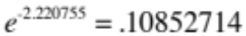), so the estimated probability of a diabetes diagnosis for the white people group would be 9.79% (.10852714 / (1+ .10852714) = 0.0979021) Based on a 95% confidence interval, this observed odds (probability) would not be judged unusual if the true odds(probability) were anywhere between 0.0824(probability=7.61%) to 0.143(probability=12.5%). A two-sided p value of p<0.001 suggests that we can with high confidence reject the null hypothesis that the odds of a diabetes diagnosis for the white people group is 0.
The black group is estimated to have odds of a diabetes diagnosis 1.93 times as large as the white group, 95% CI unadjusted for multiple comparisons: 1.08 to 3.44 times as large, then the observed would not be unusual, unadjusted for multiple comparisons: p value= 0.026 indicate the odds ratio of diabetes between black group and white group is highly statistically different from 1 (the odds of diabetes between black group and white group are not the same).
The asian group is estimated to have odds of a diabetes diagnosis 0.628 times as large as the white group, 95% CI unadjusted for multiple comparisons: 0.189 to 2.09 times as large, then the observed would not be unusual, unadjusted for multiple comparisons: p value= 0.448 indicate we can not reject the null that the odds of diabetes between asian group and white group are the same.
The other group is estimated to have odds of a diabetes diagnosis 1.84 times as large as the white group, 95% CI unadjusted for multiple comparisons: 0.394 to 8.62 times as large, then the observed would not be unusual, unadjusted for multiple comparisons: p value= 0.437 indicate we can not reject the null that the odds of diabetes between other group and white group are the same.
  - If we were to ignore issue related to multiple comparisons, what conclusions would you reach based on the p values reported in the regression output from part (a) using a 0.05 level of significance.
Ignore issue related to multiple comparisons:
Using a 0.05 level of significance, a two-sided p value of p<0.001 suggests that we can with high confidence reject the null hypothesis that the odds of a diabetes diagnosis for the white people group is 0.
P value= 0.026 indicate the odds ratio of diabetes between black group and white group is highly statistically different from 1 (the odds of diabetes between black group and white group are not the same).
P value= 0.448 indicate we can not reject the null that the odds of diabetes between asian group and white group are the same.
P value= 0.437 indicate we cannot reject the null that the odds of diabetes between other group and white group are the same.
  - Now fit a logistic regression model that uses blacks as a reference group. How would your report of formal inference differ from that that you provided in part (a)? How does this regression model relate to that in part (a)?
This still is a saturated model. Method part would change to using blacks as the baseline group. The overall chi-square test would be testing on whites asians and others, but p value of 0.0953 from the overall chi-square test is still the same, thus same inference. Odds ratios are now between the other groups and blacks, so the out put is different from a, but actually saying the same things. We can get the output of a by a little calculation of the output in b. 1/b1=b2, b3/b1=a3, b4/b1=a4
This regression model is the exact same as the one in part a, Merely “reparameterized” (coded differently). Two models are equivalent because they lead to the exact same estimated parameters. Inference about corresponding parameters will be the same no matter how it is parameterized
  - Using the regression model fit in part (d), provide an interpretation for each of the regression parameters (including the intercept.)
Intercept: This corresponds to the log odds of a diabetes diagnosis for the black people group, so the estimated odds of a diabetes diagnosis for the black people group would be 0.209 (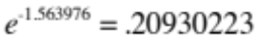), so the estimated probability of a diabetes diagnosis for the black people group would be 17.3% (.20930223 / (1+ .20930223) = 0.1730769) Based on a 95% confidence interval, this observed odds(probability) would not be judged unusual if the true odds(probability) were anywhere between 0.126(probability=11.2%) to 0.348(probability=25.8%). A two-sided p value of p<0.001 suggests that we can with high confidence reject the null hypothesis that the odds of a diabetes diagnosis for the black people group is 0.
The white group is estimated to have odds of a diabetes diagnosis 0.519 times as large as the black group, 95% CI unadjusted for multiple comparisons: 0.291 to 0.924 times as large, then the observed would not be unusual, p value unadjusted for multiple comparisons: = 0.026 indicate the odds ratio of diabetes between white group and black group is highly statistically different from 1 (the odds of diabetes between white group and black group are not the same).
The asian group is estimated to have odds of a diabetes diagnosis 0.326 times as large as the black group, 95% CI unadjusted for multiple comparisons: 0.0910 to 1.17 times as large, then the observed would not be unusual, p value unadjusted for multiple comparisons: = 0.085 indicate the odds ratio of diabetes between asian group and black group is highly statistically different from 1 (the odds of diabetes between asian group and black group are not the same).
The other group is estimated to have odds of a diabetes diagnosis 0.956 times as large as the black group, 95% CI unadjusted for multiple comparisons: 0.193 to 4.74 times as large, then the observed would not be unusual, p value unadjusted for multiple comparisons: = 0.956 indicate we can not reject the null that the odds of diabetes between other group and black group are the same.
  - If we were to ignore issue related to multiple comparisons, what conclusions would you reach based on the p values reported in the regression output from part (d) using a 0.05 level of significance.
Ignore issue related to multiple comparisons, using a 0.05 level of significance:
A two-sided p value of p<0.001 suggests that we can with high confidence reject the null hypothesis that the odds of a diabetes diagnosis for the black people group is 0.
P value = 0.026 indicate the odds ratio of diabetes between white group and black group is highly statistically different from 1 (the odds of diabetes between white group and black group are not the same).
P value = 0.085 indicate the odds ratio of diabetes between asian group and black group is highly statistically different from 1 (the odds of diabetes between asian group and black group are not the same).
P value = 0.956 indicate we can not reject the null that the odds of diabetes between other group and black group are the same.
  - What do your results from parts (c) and (f) say about the dangers of using the p values for individual regression parameters from a dummy variable regression to decide whether to include or exclude those variables in a regression model (i.e., in a “stepwise model building” procedure)?
From (c), only the p value for balck and whites is significant, but in (f) two p values , whit and black plus Asians and blacks are significant. Using these p values may lead to excluding different variables in a regression model. But these two regression model are the exact same merely “reparameterized” (coded differently). Thus should not lead to different results, so it’s dangerous to using the p values for individual regression parameters from a dummy variable regression to decide whether to include or exclude those variables in a regression model.
- Perform a statistical regression analysis evaluating an association between all-cause mortality and serum by comparing the instantaneous risk (hazard) of death over the entire period of observation across groups defined by serum LDL when fit as dummy variables using the categories suggested by the Mayo Clinic as reported on Homework #1. The Stata egen command can be used to categorize the LDL levels
egen ldlCTG = cut(ldl), at(0 70 100 130 160 190 250)
  - Include full description of your methods, appropriate descriptive statistics, and full report of your inferential statistics.
Method for descriptive statistics: Descriptive statistics for the censoring distribution included the minimum and maximum observed censoring times and the Kaplan-Meier estimates of the 10th, 50th(median), and 90th percentiles, as well as the mean time of follow-up calculated as the area under the Kaplan-Meier estimate of the censoring distribution’s survivor curve.
Descriptive statistics for serum LDL levels included the number of cases with missing data, as well as the minimum, maximum, mean, standard deviation, and the 25th, 50th(median), and 75th percentiles for the cases with available data. For the purposes of descriptive statistics of the survival probabilities by serum LDL level, serum LDL was categorized according to the Mayo Clinic guidelines: less than 70 mg/dL, 70-99 mg/dL, 100-129 mg/dL, 130-159 mg/dL, 160-189 mg/dL, and greater than or equal to 190 mg/dL. Within these categories, Kaplan-Meier estimates of survival were calculated and graphed, and estimates of the 2 and 5 year survival probabilities, as well as the 10th and 20th percentiles of the survival distribution and the restricted mean survival during a period of observation that all LDL strata still had some subjects at risk (5.75 years).
Descriptive statistics: The study consisted of 735 subjects who were followed for death from any cause for a Kaplan-Meier estimated average of 5.33 years (median 5.66 years, range 5.00 to 5.91 years), during which time 133 deaths were observed. Serum LDL measurements at the time of study enrollment were not available on 10 subjects, two of whom were observed to die after 0.189 and 0.657 years of observation, with the remaining subjects still alive after 5.05 to 5.91 years of observation. In the 725 subjects with available serum LDL measurements at enrollment, the mean LDL was 126 mg/dL (SD 33.6 mg/dL, range 11 to 247 mg/dL).
Table 1 presents estimates of the survival distribution within strata defined by serum LDL and in the combined sample from the 725 subjects with available LDL measurements. The greatest difference in survival distributions is apparent when comparing those individuals having the lowest serum LDL levels (less than 70 mg/dL) at times after 2 years of follow-up. The 5 year survival probability is lowest in that group (59.1%) and is observed highest in the subjects having serum LDL between 160 and 189 mg/dL inclusive (88.0%). On average, the subjects in the lowest LDL stratum were estimated to average 4.91 years of life during the first 5.75 years following study enrollment, while the other strata averaged from 5.23 to 5.45 years. Figure 1 presents the Kaplan-Meier survival probability estimates graphically, where it is again the lowest LDL group that shows the most markedly different survival distribution.

Table 1: Kaplan-Meier based estimates of distribution of time from study enrollment to death from any cause for subjects having serum LDL measurements at baseline.
 | Serum LDL level (mg/dL)
 | 11 – 69 | 70 – 99 | 100 – 129 | 130 – 159 | 160 – 189 | 190 – 247 | All subjects available***
N Subjects | 22 | 143 | 228 | 225 | 83 | 24 | 725
N Deaths | 10 | 28 | 44 | 34 | 11 | 4 | 131
2 Year Survival Probability | 100% | 95.8% | 93.9% | 95.6% | 98.8% | 95.8% | 95.6%
5 Year Survival Probability | 59.1% | 83.2% | 81.1% | 87.1% | 88.0% | 83.3% | 86.0%
10th Percentiles of Survival | 3.46 y | 3.80 y | 3.41 y | 4.30 y | 4.53 y | 4.13 y | 3.66 y
20th Percentiles of Survival* | 3.55 y | 5.44 y | 5.36 y | NA | NA | NA | 5.54 y
5.75 Year Restricted Mean of Survival** | 4.91 y | 5.24 y | 5.23 y | 5.35 y | 5.45 y | 5.32 y | 5.29 y
*Based on Kaplan-Meier estimates computed within strata defined by LDL and overall. NA indicates that the corresponding percentile is not estimable with the available data.
**Average number of years alive during the first 5.75 years following study enrollment, as computed by the area under Kaplan-Meier survival curves computed within strata defined by LDL and overall.
***Ten of the 735 subjects in the study population were missing baseline serum LDL measurements. Two of those subjects were observed to die after 0.189 y and 0.657 years of observation. The remaining 8 subjects with missing LDL data were still alive at the end of their observation period 5.03 to 5.91 years after study enrollment.

Figure 1: Kaplan-Meier based estimates of distribution of time from study enrollment to death from any cause for 725 subjects having serum LDL measurements at baseline.
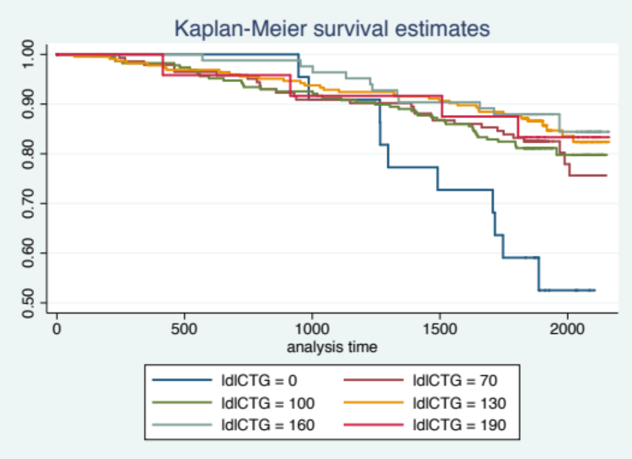
Method for Inference: The continuous variable serum LDL is recoded as a dummy variable cutting at 70 mg/dL, 100 mg/dL, 130 mg/dL, 160 mg/dL, 190 mg/dL. Proportional hazards regression model is used to assess the association between all cause mortality and serum LDL level using a dummy variable for LDL groups and treating the 0-69 mg/dL group as baseline. Maximum partial likelihood method is used to find parameter estimates. And Wald-based method is used to give the two sided p values and confidence intervals for parameters. Huber-white sandwich method is used to give the robust standard error for parameters. Quantification of association between all cause mortality and LDL was tested by the overall chi-square test with a two-sided p values to test the rest LDL groups simultaneously.
Inference: Data was available on 725 subjects having mean serum LDL of 126 mg/dL (SD 33.6 mg/dL; range 11 – 247 mg/dL). During an average of 5.33 years of observation, 131 of those subjects were observed to die.
From the proportional hazard regression analysis, we estimated that the risk of death for subjects with LDL level 70-99 mg/dL is 60.2% times lower (P value=0.008) than that in the group with LDL level 11-69 mg/dL. And with 95% confidence interval, our observation would not be atypical if the true hazard ratio between LDL 70-99mg/dl and LDL 11-69 mg/dL is from 0.203 to 0.782.
The risk of death for subjects with LDL level 100-129 mg/dL is 60.7% times lower (P value=0.004) than that in the group with LDL level 11-69 mg/dL. And our observation would not be atypical if the true hazard ratio between LDL 100-129 mg/dl and LDL 11-69 mg/dL is from 0.207 to 0.744.
The risk of death for subjects with LDL level 130-159 mg/dL is 70.6% times lower (P value<0.001) than that in the group with LDL level 11-69 mg/dL. And our observation would not be atypical if the true hazard ratio between LDL 130-159 mg/dl and LDL 11-69 mg/dL is from 0.152 to 0.568.
The risk of death for subjects with LDL level 160-189 mg/dL is 74.3% times lower (P value<0.001) than that in the group with LDL level 11-69 mg/dL. And our observation would not be atypical if the true hazard ratio between LDL 160-189 mg/dl and LDL 11-69 mg/dL is from 0.113 to 0.580.
The risk of death for subjects with LDL level 190-249 mg/dL is 68.3% times lower (P value=0.048) than that in the group with LDL level 11-69 mg/dL. And our observation would not be atypical if the true hazard ratio between LDL 190-249 mg/dl and LDL 11-69 mg/dL is from 0.101 to 0.989.
The P value for the overall Chi square test is 0.0087. Thus with high confidence, we can reject the null the instantaneous risk (hazard) of death over the entire period of observation across groups defined by serum LDL are the same. Thus the instantaneous risk of all cause death is associated with serum LDL level.
  - Provide an interpretation for each parameter in your regression model, including the intercept.
The intercept is not printed by STATA as there are too many parameters for the intercept to get a good estimate. The exponentiated intercept from the proportional hazards model is the estimated hazard for the subjects in the group with LDL 11-69 mg/dL.
The estimated (exponentiated) parameter is the hazard ratio between group with LDL 70-99 mg/dl and group with LDL 11-69 mg/dL. The point estimate is 0.398. The risk of death for subjects with LDL level 70-99 mg/dL is 60.2% times lower (P value=0.008) than that in the group with LDL level 11-69 mg/dL. And with 95% confidence interval, our observation would not be unusual if the true hazard ratio between LDL 70-99mg/dl and LDL 11-69 mg/dL is from 0.203 to 0.782.
The estimated (exponentiated) parameter is the hazard ratio between group with LDL 100-129 mg/dl and group with LDL 11-69 mg/dL. The point estimate is 0.393. The risk of death for subjects with LDL level 100-129 mg/dL is 60.7% times lower (P value=0.004) than that in the group with LDL level 11-69 mg/dL. And our observation would not be unusual if the true hazard ratio between LDL 100-129 mg/dl and LDL 11-69 mg/dL is from 0.207 to 0.744.
The estimated (exponentiated) parameter is the hazard ratio between group with LDL 130-159 mg/dl and group with LDL 11-69 mg/dL. The point estimate is 0.294. The risk of death for subjects with LDL level 130-159 mg/dL is 70.6% times lower (P value<0.001) than that in the group with LDL level 11-69 mg/dL. And our observation would not be unusual if the true hazard ratio between LDL 130-159 mg/dl and LDL 11-69 mg/dL is from 0.152 to 0.568.
The estimated (exponentiated) parameter is the hazard ratio between group with LDL 160-189 mg/dl and group with LDL 11-69 mg/dL. The point estimate is 0.257. The risk of death for subjects with LDL level 160-189 mg/dL is 74.3% times lower (P value<0.001) than that in the group with LDL level 11-69 mg/dL. And our observation would not be unusual if the true hazard ratio between LDL 160-189 mg/dl and LDL 11-69 mg/dL is from 0.113 to 0.580.
The estimated (exponentiated) parameter is the hazard ratio between group with LDL 190-249 mg/dl and group with LDL 11-69 mg/dL. The point estimate is 0.317. The risk of death for subjects with LDL level 190-249 mg/dL is 68.3% times lower (P value=0.048) than that in the group with LDL level 11-69 mg/dL. And our observation would not be unusual if the true hazard ratio between LDL 190-249 mg/dl and LDL 11-69 mg/dL is from 0.101 to 0.989.
  - What analysis would you perform to assess whether the regression model used in this problem provides a “better fit” than does a model that uses only a continuous linear term for LDL? What is the result of such an analysis?
We could add a linear term of LDL into the model along with the dummy variables and then test the dummy variables together. The p value for the chi square test is 0.399. This is not significant, thus the liner fit is better.
  - For each population defined by serum LDL value, compute the hazard ratio relative to a group having serum LDL of 160 mg/dL. (This will be used in problem 4). This can be effected by generating fitted hazard ratio estimates for each individual in the sample, and then dividing that fitted value by the fitted value for a subject having a LDL of 160 mg/dL.
- Perform a statistical regression analysis evaluating an association between all-cause mortality and serum by comparing the instantaneous risk (hazard) of death over the entire period of observation across groups defined by serum LDL when fit as linear splines using the categories suggested by the Mayo Clinic as reported on Homework #1. The Stata mkspline command can be used to create the predictors that can be used in a regression
mkspline ldl0 70 ldl70 100 ldl100 130 ldl130 160 ldl160 190 ldl190 = ldl
  - Include full description of your methods, appropriate descriptive statistics, and full report of your inferential statistics.
Method for descriptive statistics: Descriptive statistics for the censoring distribution included the minimum and maximum observed censoring times and the Kaplan-Meier estimates of the 10th, 50th(median), and 90th percentiles, as well as the mean time of follow-up calculated as the area under the Kaplan-Meier estimate of the censoring distribution’s survivor curve.
Descriptive statistics for serum LDL levels included the number of cases with missing data, as well as the minimum, maximum, mean, standard deviation, and the 25th, 50th(median), and 75th percentiles for the cases with available data. For the purposes of descriptive statistics of the survival probabilities by serum LDL level, serum LDL was categorized according to the Mayo Clinic guidelines: less than 70 mg/dL, 70-99 mg/dL, 100-129 mg/dL, 130-159 mg/dL, 160-189 mg/dL, and greater than or equal to 190 mg/dL. Within these categories, Kaplan-Meier estimates of survival were calculated and graphed, and estimates of the 2 and 5 year survival probabilities, as well as the 10th and 20th percentiles of the survival distribution and the restricted mean survival during a period of observation that all LDL strata still had some subjects at risk (5.75 years).
Descriptive statistics: The study consisted of 735 subjects who were followed for death from any cause for a Kaplan-Meier estimated average of 5.33 years (median 5.66 years, range 5.00 to 5.91 years), during which time 133 deaths were observed. Serum LDL measurements at the time of study enrollment were not available on 10 subjects, two of whom were observed to die after 0.189 and 0.657 years of observation, with the remaining subjects still alive after 5.05 to 5.91 years of observation. In the 725 subjects with available serum LDL measurements at enrollment, the mean LDL was 126 mg/dL (SD 33.6 mg/dL, range 11 to 247 mg/dL).
Table 1 presents estimates of the survival distribution within strata defined by serum LDL and in the combined sample from the 725 subjects with available LDL measurements. The greatest difference in survival distributions is apparent when comparing those individuals having the lowest serum LDL levels (less than 70 mg/dL) at times after 2 years of follow-up. The 5 year survival probability is lowest in that group (59.1%) and is observed highest in the subjects having serum LDL between 160 and 189 mg/dL inclusive (88.0%). On average, the subjects in the lowest LDL stratum were estimated to average 4.91 years of life during the first 5.75 years following study enrollment, while the other strata averaged from 5.23 to 5.45 years. Figure 1 presents the Kaplan-Meier survival probability estimates graphically, where it is again the lowest LDL group that shows the most markedly different survival distribution.
 | Serum LDL level (mg/dL)
 | 11 – 69 | 70 – 99 | 100 – 129 | 130 – 159 | 160 – 189 | 190 – 247 | All subjects available***
N Subjects | 22 | 143 | 228 | 225 | 83 | 24 | 725
N Deaths | 10 | 28 | 44 | 34 | 11 | 4 | 131
2 Year Survival Probability | 100% | 95.8% | 93.9% | 95.6% | 98.8% | 95.8% | 95.6%
5 Year Survival Probability | 59.1% | 83.2% | 81.1% | 87.1% | 88.0% | 83.3% | 86.0%
10th Percentiles of Survival | 3.46 y | 3.80 y | 3.41 y | 4.30 y | 4.53 y | 4.13 y | 3.66 y
20th Percentiles of Survival* | 3.55 y | 5.44 y | 5.36 y | NA | NA | NA | 5.54 y
5.75 Year Restricted Mean of Survival** | 4.91 y | 5.24 y | 5.23 y | 5.35 y | 5.45 y | 5.32 y | 5.29 y
Table 1: Kaplan-Meier based estimates of distribution of time from study enrollment to death from any cause for subjects having serum LDL measurements at baseline.
*Based on Kaplan-Meier estimates computed within strata defined by LDL and overall. NA indicates that the corresponding percentile is not estimable with the available data.
**Average number of years alive during the first 5.75 years following study enrollment, as computed by the area under Kaplan-Meier survival curves computed within strata defined by LDL and overall.
***Ten of the 735 subjects in the study population were missing baseline serum LDL measurements. Two of those subjects were observed to die after 0.189 y and 0.657 years of observation. The remaining 8 subjects with missing LDL data were still alive at the end of their observation period 5.03 to 5.91 years after study enrollment.

Figure 1: Kaplan-Meier based estimates of distribution of time from study enrollment to death from any cause for 725 subjects having serum LDL measurements at baseline.
Method for Inference: The continuous variable serum LDL is recoded as spline variables using knots at 70 mg/dL, 100 mg/dL, 130 mg/dL, 160 mg/dL, 190 mg/dL. Proportional hazards regression model is used to assess the association between all cause mortality and serum LDL level using a spline variable for LDL. Maximum partial likelihood method is used to find parameter estimates. And Wald-based method is used to give the two sided p values and confidence intervals for parameters. Huber-white sandwich method is used to give the robust standard error for parameters. Quantification of association between all cause mortality and LDL was tested by the overall chi-square test with a two-sided p values to test all the LDL groups have the same slope(hazard) simultaneously.
Inference: Data was available on 725 subjects having mean serum LDL of 126 mg/dL (SD 33.6 mg/dL; range 11 – 247 mg/dL). During an average of 5.33 years of observation, 131 of those subjects were observed to die. From the proportional hazard regression analysis, we estimated that in the group with LDL level 11-69 mg/dL, the risk of death for subjects is 2.19% times lower (P value=0.019) as LDL increases by 1 mg/dL (hazard ratio=0.978). Based on a 95% confidence interval, this observed hazard ratio suggesting lower death rates for groups of patients with higher LDL levels would not be judged unusual if the true instantaneous risk of death were anywhere from 0.367% to 3.98% lower in a group having baseline serum LDL 1 mg/dL higher than that in another group (95% CI for hazard ratio 0.960 to 0.996) with LDL level in 11-69 mg/dL.
In the group with LDL level 70-99 mg/dL, the risk of death for subjects is 2.03% times lower (P value=0.139) as LDL increases by 1 mg/dL (hazard ratio=0.980). Based on a 95% confidence interval, this observed hazard ratio suggesting lower death rates for groups of patients with higher LDL levels would not be judged unusual if the true instantaneous risk of death were anywhere from 4.65% lower to 0.670% higher in a group having baseline serum LDL 1 mg/dL higher than that in another group (95% CI for hazard ratio 0.953 to 1.0067) with LDL level in 70-99 mg/dL.
In the group with LDL level 100-129 mg/dL, the risk of death for subjects is 0.229% times lower (P value=0.835) as LDL increases by 1 mg/dL (hazard ratio=0.998). Based on a 95% confidence interval, this observed hazard ratio suggesting lower death rates for groups of patients with higher LDL levels would not be judged unusual if the true instantaneous risk of death were anywhere from 2.36% lower to 1.95% higher in a group having baseline serum LDL 1 mg/dL higher than that in another group (95% CI for hazard ratio 0.976 to 1.0195) with LDL level in 100-129 mg/dL.
In the group with LDL level 130-159 mg/dL, the risk of death for subjects is 0.361% times higher (P value=0.773) as LDL increases by 1 mg/dL (hazard ratio=1.00361). Based on a 95% confidence interval, this observed hazard ratio suggesting higher death rates for groups of patients with higher LDL levels would not be judged unusual if the true instantaneous risk of death were anywhere from 2.06% lower to 2.84% higher in a group having baseline serum LDL 1 mg/dL higher than that in another group (95% CI for hazard ratio 0.979 to 1.0284) with LDL level in 130-159 mg/dL.
In the group with LDL level 160-189 mg/dL, the risk of death for subjects is 2.91% times lower (P value=0.181) as LDL increases by 1 mg/dL (hazard ratio=0.971). Based on a 95% confidence interval, this observed hazard ratio suggesting lower death rates for groups of patients with higher LDL levels would not be judged unusual if the true instantaneous risk of death were anywhere from 7.02% lower to 1.38% higher in a group having baseline serum LDL 1 mg/dL higher than that in another group (95% CI for hazard ratio 0.9298 to 1.0138) with LDL level in 160-189 mg/dL.
In the group with LDL level 190-247 mg/dL, the risk of death for subjects is 2.88% times higher (P value=0.261) as LDL increases by 1 mg/dL (hazard ratio=1.0288). Based on a 95% confidence interval, this observed hazard ratio suggesting lower death rates for groups of patients with higher LDL levels would not be judged unusual if the true instantaneous risk of death were anywhere from 2.07% lower to 8.10% higher in a group having baseline serum LDL 1 mg/dL higher than that in another group (95% CI for hazard ratio 0.979 to 1.0810) with LDL level in 190-247 mg/dL.
The P value for the overall Chi square test is 0.0788. Thus there isn’t enough evidence to reject the null that the instantaneous risk of all cause death is not associated with serum LDL level.
  - Provide an interpretation for each parameter in your regression model, including the intercept.
The minimum for LDL is 11, 0 is out of our range, thus there is no interpretation for an intercept.
The first estimated (exponentiated) parameter is the hazard ratio between group within the LDL 11-69 mg/dl as LDL increases by 1 mg/dL. In the group with LDL level 11-69 mg/dL, the risk of death for subjects is 2.19% times lower (P value=0.019) as LDL increases by 1 mg/dL (hazard ratio=0.978). Based on a 95% confidence interval, this observed hazard ratio suggesting lower death rates for groups of patients with higher LDL levels would not be judged unusual if the true instantaneous risk of death were anywhere from 0.367% to 3.98% lower in a group having baseline serum LDL 1 mg/dL higher than that in another group (95% CI for hazard ratio 0.960 to 0.996) with LDL level in 11-69 mg/dL.
The first estimated (exponentiated) parameter is the hazard ratio between group within the LDL 70-99 mg/dl as LDL increases by 1 mg/dL. In the group with LDL level 70-99 mg/dL, the risk of death for subjects is 2.03% times lower (P value=0.139) as LDL increases by 1 mg/dL (hazard ratio=0.980). Based on a 95% confidence interval, this observed hazard ratio suggesting lower death rates for groups of patients with higher LDL levels would not be judged unusual if the true instantaneous risk of death were anywhere from 4.65% lower to 0.670% higher in a group having baseline serum LDL 1 mg/dL higher than that in another group (95% CI for hazard ratio 0.953 to 1.0067) with LDL level in 70-99 mg/dL.
The first estimated (exponentiated) parameter is the hazard ratio between group within the LDL 100-129 mg/dl as LDL increases by 1 mg/dL.In the group with LDL level 100-129 mg/dL, the risk of death for subjects is 0.229% times lower (P value=0.835) as LDL increases by 1 mg/dL (hazard ratio=0.998). Based on a 95% confidence interval, this observed hazard ratio suggesting lower death rates for groups of patients with higher LDL levels would not be judged unusual if the true instantaneous risk of death were anywhere from 2.36% lower to 1.95% higher in a group having baseline serum LDL 1 mg/dL higher than that in another group (95% CI for hazard ratio 0.976 to 1.0195) with LDL level in 100-129 mg/dL.
The first estimated (exponentiated) parameter is the hazard ratio between group within the LDL 130-159 mg/dl as LDL increases by 1 mg/dL.In the group with LDL level 130-159 mg/dL, the risk of death for subjects is 0.361% times higher (P value=0.773) as LDL increases by 1 mg/dL (hazard ratio=1.00361). Based on a 95% confidence interval, this observed hazard ratio suggesting higher death rates for groups of patients with higher LDL levels would not be judged unusual if the true instantaneous risk of death were anywhere from 2.06% lower to 2.84% higher in a group having baseline serum LDL 1 mg/dL higher than that in another group (95% CI for hazard ratio 0.979 to 1.0284) with LDL level in 130-159 mg/dL.
The first estimated (exponentiated) parameter is the hazard ratio between group within the LDL 160-189 mg/dl as LDL increases by 1 mg/dL.In the group with LDL level 160-189 mg/dL, the risk of death for subjects is 2.91% times lower (P value=0.181) as LDL increases by 1 mg/dL (hazard ratio=0.971). Based on a 95% confidence interval, this observed hazard ratio suggesting lower death rates for groups of patients with higher LDL levels would not be judged unusual if the true instantaneous risk of death were anywhere from 7.02% lower to 1.38% higher in a group having baseline serum LDL 1 mg/dL higher than that in another group (95% CI for hazard ratio 0.9298 to 1.0138) with LDL level in 160-189 mg/dL.
The first estimated (exponentiated) parameter is the hazard ratio between group within the LDL 190-247 mg/dl as LDL increases by 1 mg/dL. In the group with LDL level 190-247 mg/dL, the risk of death for subjects is 2.88% times higher (P value=0.261) as LDL increases by 1 mg/dL (hazard ratio=1.0288). Based on a 95% confidence interval, this observed hazard ratio suggesting lower death rates for groups of patients with higher LDL levels would not be judged unusual if the true instantaneous risk of death were anywhere from 2.07% lower to 8.10% higher in a group having baseline serum LDL 1 mg/dL higher than that in another group (95% CI for hazard ratio 0.979 to 1.0810) with LDL level in 190-247 mg/dL.
  - What analysis would you perform to assess whether the regression model used in this problem provides a “better fit” than does a model that uses only a continuous linear term for LDL? What is the result of such an analysis?
We could add a linear term of LDL into the model along with the spline variables and then test the spline variables together. The p value for the chi square test is 0.0788. This is not significant, thus the liner fit is better.
  - For each population defined by serum LDL value, compute the hazard ratio relative to a group having serum LDL of 160 mg/dL. (This will be used in problem 4). This can be effected by generating fitted hazard ratio estimates for each individual in the sample, and then dividing that fitted value by the fitted value for a subject having a LDL of 160 mg/dL.
- By answering the following questions, compare the relative advantages and disadvantages of the various statistical analysis strategies we have considered in Homeworks 1-4 and problems 2 and 3 in this homework.
  - What advantages do the regression strategies used in Homeworks 4 and 5 provide over the approaches used in Homeworks 1-3?
In HW4 and HW5 we deal with the censored data with hazards instead of throwing away data with observed time greater than 5 years. Most of the information is used comparing to the approaches used in HW 1-3. The disadvantage is that we can only get hazards while in HW 1-3 we have mean LDL from mortality groups and mortality in different LDL groups, these statistics can be useful. In HW4 and HW5 the variable LDL is used as a continuous variable (though may be coded as dummy variables and spline variables).
  - Comment on any similarities or differences of the fitted values from the three models fit in Homework 4 and the two models fit in problems 2 and 3 of this homework.
The figure below shows the fitted lines from the five models. HW4A is the linear fit. HW4B is the log fit. HW4C is the quadratic fit. HW5A is a linear fit with dummy variables. And HW5B is a linear fit with spline variables. In all 5 cases, the models predict a trend that is predominantly downward with higher LDL. There is not tremendous difference between the five models over the mid range of LDL, and the greatest differences between the models occur in the lowest ranges of LDL, where our data is relatively sparse. The fits from the logarithmic transformation and the quadratic function are remarkably similar. The difference between HW5A line and other lines are bigger over the lower range of LDL. Over the mid range of LDL, the spline linear fit line is below other lines and also has a upward tendency like quadratic fit line over higher range of LDL. However we could not conclude that higher LDL has increasing death risk. It would require a much larger sample size and a more careful analysis to establish whether there is really a tendency for both lower and higher LDL to be associated with higher risk of death in this population.

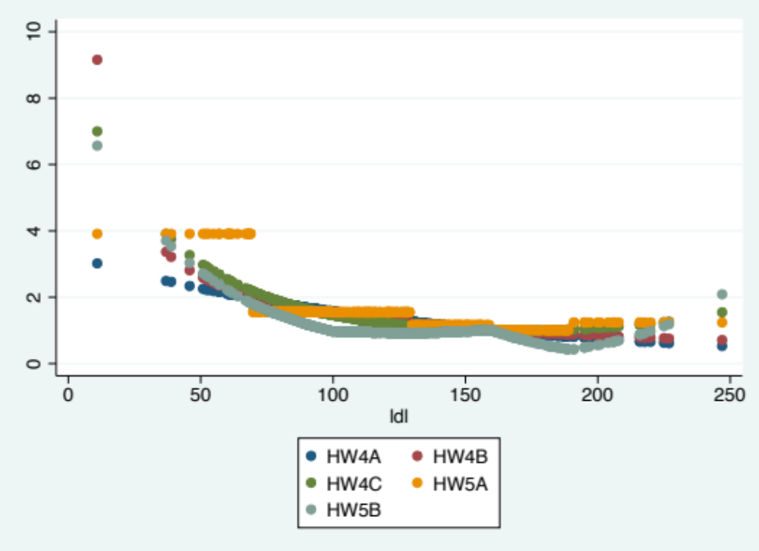
  - A priori, of all the analyses we have considered for exploring an (unadjusted) association between all cause mortality and serum LDL in an elderly population, which one would you prefer and why?
The fits from the logarithmic transformation and the quadratic function are remarkably similar. To the extent that this is an accurate representation of the true association, the greater interpretability of the logarithmic transformation makes that more attractive to me. In this case, the fit line with untransformed predictor variable and the fit line with log-transformed predictor variable fits well. And from previous analysis, we had strong evidence to show that the use of more flexible methods (dummy variable and spline line) may cause precision losing due to loss of degree of freedoms of the model. And from previous scientific knowledge, we know that the use of log-transformed predictor variable is better.

Discussion Sections: February 3 - 7, 2014

We continue to discuss the dataset regarding FEV and smoking in children. Come do discussion section prepared to describe descriptive statistics, especially as they relate to confounding, precision, effect modification, and the impact of heteroscedasticity.

