Biost 518: Applied Biostatistics II
Biost 515: Biostatistics II
Emerson, Winter 2014

Homework #7
February 17, 2014

Written problems: To be submitted as a MS-Word compatible file to the class Catalyst dropbox by 9:30 am on Monday, February 24, 2014. See the instructions for peer grading of the homework that are posted on the web pages.

Note: You may find the keys to homeworks 1 and 3 from the Winter 2006 offering of Biost 518 of use in solving the questions on this homework.

On this (as all homeworks) Stata / R code and unedited Stata / R output is TOTALLY unacceptable. Instead, prepare a table of statistics gleaned from the Stata output. The table should be appropriate for inclusion in a scientific report, with all statistics rounded to a reasonable number of significant digits. (I am interested in how statistics are used to answer the scientific question.)

Unless explicitly told otherwise in the statement of the problem, in all problems requesting “statistical analyses” (either descriptive or inferential), you should present both
- Methods: A brief sentence or paragraph describing the statistical methods you used. This should be using wording suitable for a scientific journal, though it might be a little more detailed. A reader should be able to reproduce your analysis. DO NOT PROVIDE Stata OR R CODE.
- Inference: A paragraph providing full statistical inference in answer to the question. Please see the supplementary document relating to “Reporting Associations” for details.

Questions 1 and 2 suppose that you are reading a scientific article in a journal with inadequate statistical review. The scientific question addressed by the article is the association between blood lipid profiles (especially total cholesterol), biomarkers of inflammation (fibrinogen), and mortality from cardiovascular disease. The authors were also interested in the role of race (as categorized by Caucasian and Noncaucasian) in the relationship between sex and the serum measurements of total cholesterol and fibrinogen.

The authors reported gathering data on 3,015 subjects, of whom 1,258 were male and 1,757 were female. The subjects were further characterized as 2,534 Caucasians, 481 Noncaucasians. The data analysis presented in the manuscript is limited to the means and standard errors of the serum measures within subgroups as given in the following table.

Table 1. Means (standard errors) of serum cholesterol and fibrinogen according to patient sex and race.
 | Males |  | Females
 | Caucasians | Noncaucasians | Caucasians | Noncaucasians
Cholesterol (mg/dl) | 197.5 (1.092) | 197.9 (2.557) | 222.8 (1.103) | 213.6 (2.321)
Fibrinogen (mg/dl) | 317.8 (2.126) | 333.7 (5.628) | 320.7 (1.627) | 349.4 (4.643)

- You desire to do a more careful evaluation of the evidence at hand for associations between sex and cholesterol. You therefore desire to compute estimates, 95% confidence intervals, and P values to address questions of associations within subgroups, associations adjusted for race, and effect modification. In addressing the following questions, provide a sentence that interprets your inferential statistics in a manner suitable for inclusion in a scientific journal article. Avoid statistical jargon. (You note that without the sample sizes by subgroup, you will not be able to use the exact statistical methods (i.e., t tests) that you might otherwise have, but you will be able to perform analyses based on large sample approximations and the fact that sample means are approximately normally distributed. The Stata function normal() will return the cumulative distribution function for the standard normal. Hence,
di normal(1.96)
will display 0.9750021. In R, the equivalent function is pnorm().)
  - Are mean cholesterol levels associated with sex in Caucasians? (Recall that the standard error of two independent statistics is the square root of the sum of the squares of the individual standard errors. Thus calculate the standard error for the difference in mean cholesterol using the standard errors for the males and females.)
Methods.
We perform the following calculations:
The difference in sample means
Estimate of standard error for comparison
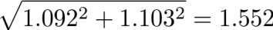
Computation of Z-score to test the null hypothesis
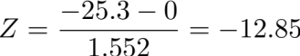
95% CI
P-values were computed using STATA.
Inference. Mean cholesterol levels were found to be 25.30 mg/dL lower in Caucasian males than Caucasian females. Based on a two-sided p-value<0.0001, such a difference was found to be sufficient to reject the null hypothesis of no difference in cholesterol levels in groups defined by sex. Based on a 95% confidence interval, we find that the observed difference is not atypical if the true difference in mean cholesterol were 22.26 mg/dL to 28.34 mg/dL lower in Caucasian males than Caucasian females.

  - Are mean cholesterol levels associated with sex in Noncaucasians?
Methods.
We perform the following calculations:
The difference in sample means
Estimate of standard error for comparison
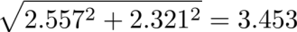
Computation of Z-score to test the null hypothesis
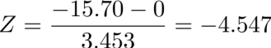
95% CI
P-values were computed using STATA.
Inference. Mean cholesterol levels were found to be 15.70 mg/dL lower in Noncaucasian males than Noncaucasian females. Based on a two-sided p-value<0.0001, such a difference was found to be sufficient to reject the null hypothesis of no difference in cholesterol levels in groups defined by sex. Based on a 95% confidence interval, we find that the observed difference is not atypical if the true difference in mean cholesterol levels were 8.932 mg/dL to 22.47 mg/dL lower in Caucasian males than Caucasian females.

  - Are mean cholesterol levels associated with sex after adjustment for race? Provide adjusted estimates using both importance and efficiency weights.

An approach that can be used here is to find a weighted average of the measures of effect in each race group. Hence, you might use a weighted average of the estimates Δ_{C} and Δ_{N} you derived in parts a and b, respectively: Let the adjusted estimated be defined according to
Δ_{adj} = (w_{C} × Δ_{C} + w_{N} × Δ_{N}) / (w_{C} + w_{N})
where w_{C} and w_{N} are relative weights to be applied to the two strata. (Note that the equation becomes simpler if we ensure that the relative weights sum to 1.) The SE of the adjusted estimate of effect is then found by using the properties of variances. Recall that when multiplying a random variable by a constant, Var(cX) = c² Var(X). Hence, you can find the standard error of the adjusted estimate can be found by
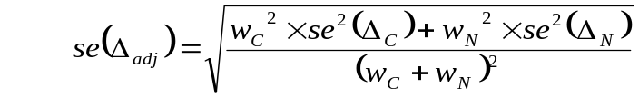
Many options could be considered for choosing the weights. Two that might be considered include:
    - Importance weights: We weight each stratum according to its relative importance in the population of interest. This could be estimated from our sample (84.05% of our sample was Caucasian, so we could assume that that was also the frequency in the general population of elderly adults) or taken from, say, US census data (86.37% of US residents aged 65 years or older are Caucasian).
    - Efficiency weights: Under the assumption of no effect modification, the most efficient analysis would be to weight each stratum in proportion to the inverse of the square of the standard error of the stratum specific estimate.
Methods
Using importance weights, we perform the following calculations:
The weighted average of the difference
Estimated standard error for the weighted average
Z-score
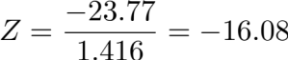
95% CI
P-value was calculated using STATA
Similar calculations were performed using efficiency weights (0.8319 for Caucasians and 0.1681 for Noncaucasians).
The weighted average of the difference is -23.68
Standard error is 1.416
Z-score is -16.72
95% CI (-26.45, -20.90)

Inference (importance weights)
After adjustment for race, mean cholesterol levels were found to be 23.77 mg/dL higher in females than males. Such a difference was sufficient to reject the null hypothesis of no differences in mean cholesterol levels between groups defined by sex (P<0.0001). Based on a 95% confidence interval, we find that the observed difference in mean cholesterol levels would not be unusual if the true difference in mean cholesterol was such that female subjects of the same race had cholesterol level 20.99 mg/dL to 26.54 mg/dL higher than male subjects of the same race.

Inference (efficiency weights)
After adjustment for race, mean cholesterol levels were found to be 23.68 mg/dL higher in females than males. Such a difference was sufficient to reject the null hypothesis of no differences in mean cholesterol levels between groups defined by sex (P<0.0001). Based on a 95% confidence interval, we find that the observed difference in mean cholesterol levels would not be unusual if the true difference in mean cholesterol was such that female subjects of the same race had cholesterol level 20.90 mg/dL to 26.45 mg/dL higher than male subjects of the same race.

  - Does race modify the association between mean cholesterol level and sex?
Methods
Difference of the differences of sample means
-25.3 – (-15.7) = -9.60
Standard error estimate
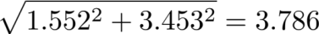
Z-score (-9.60-0)/3.786=-2.536
95% CI (-17.02, -2.179)
P-value was calculated using STATA
Inference
The difference in mean cholesterol across different sexes was found to be 9.60 mg/dL higher in Caucasians than in Noncaucasians. Such a difference was sufficiently extreme to reject the null hypothesis of no effect modification by race in the association between mean cholesterol level and sex (P=0.0112). Based on a 95% confidence interval, we find that the observed difference in the association between mean cholesterol level and sex across race groups would not be unusual if the true difference in effect were such that Caucasians had mean difference in cholesterol across sexes 2.179 mg/dL to 17.02 mg/dL higher than that in Noncaucasians.

- You also desire to do a more careful evaluation of the evidence at hand for fibrinogen. You therefore answer the questions of problem 1 using the statistics for fibrinogen.
  - Are mean fibrinogen levels associated with sex in Caucasians
Methods.
We perform the following calculations:
The difference in sample means
317.8-320.7=-2.90
Estimate of standard error for comparison
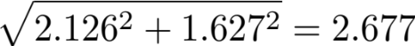
Computation of Z-score to test the null hypothesis
Z=(-2.9-0)/2.677=-1.594
95% CI
P-values were computed using STATA.
Inference. Mean fibrinogen levels were found to be 2.90 mg/dL lower in Caucasian males than Caucasian females. Based on a two-sided p-value=0.1109, such a difference was not found to be sufficiently extreme to reject the null hypothesis of no difference in fibrinogen levels in groups defined by sex. Based on a 95% confidence interval, we find that the observed difference is not atypical if the true difference in mean fibrinogen were 8.147 mg/dL lower to 2.347 mg/dL higher in Caucasian males than Caucasian females.

  - Are mean fibrinogen levels associated with sex in Noncaucasians?
Methods.
We perform the following calculations:
The difference in sample means
333.7-349.4=-15.7
Estimate of standard error for comparison

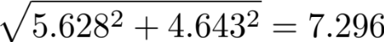
Computation of Z-score to test the null hypothesis
Z=(-15.7-0)/7.296=-2.152
95% CI
P-values were computed using STATA.
Inference. Mean fibrinogen levels were found to be 15.70 mg/dL lower in Noncaucasian males than Noncaucasian females. Based on a two-sided p-value=0.0314, such a difference was found to be sufficiently extreme to reject the null hypothesis of no difference in fibrinogen levels in groups defined by sex. Based on a 95% confidence interval, we find that the observed difference is not atypical if the true difference in mean cholesterol levels were 1.400 mg/dL to 30.00 mg/dL lower in Caucasian males than Caucasian females.

  - Are mean fibrinogen levels associated with sex after adjustment for race?
Methods
Using importance weights, we perform the following calculations:
The weighted average of the difference
Estimated standard error for the weighted average
Z-score
Z=(-4.942-0)/2.533=-1.951
95% CI
Similar calculations were performed using efficiency weights (0.8319 for Caucasians and 0.1681 for Noncaucasians).
The weighted average of the difference
Standard error
Z-score is -1.987
95% CI
P-values were calculated using STATA

Inference (importance weights)
After adjustment for race, mean fibrinogen levels were found to be 4.942 mg/dL higher in females than males. Such a difference was not sufficiently extreme to reject the null hypothesis of no differences in mean cholesterol levels between groups defined by sex (P=0.0512). Based on a 95% confidence interval, we find that the observed difference in mean fibrinogen levels would not be unusual if the true difference in mean fibrinogen was such that female subjects of the same race had cholesterol level 0.0227 mg/dL lower to 9.907 mg/dL higher than male subjects of the same race.

Inference (efficiency weights)
After adjustment for race, mean cholesterol levels were found to be 5.052 mg/dL higher in females than males. Such a difference was sufficiently extreme to reject the null hypothesis of no differences in mean fibrinogen levels between groups defined by sex (P=0.0469). Based on a 95% confidence interval, we find that the observed difference in mean fibrinogen levels would not be unusual if the true difference in mean fibrinogen was such that female subjects of the same race had fibrinogen level 0.0697 mg/dL to 10.03 mg/dL higher than male subjects of the same race.

  - Does race modify the association between mean fibrinogen level and sex?
Methods
Difference of the differences of sample means
-2.9 – (-15.7) = 12.80
Standard error estimate
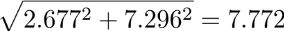
Z-score (-12.8-0)/7.772=-1.647
95% CI (-2.433, 28.03)
P-value was calculated using STATA
Inference
The difference in mean fibrinogen across different sexes was found to be 12.80 mg/dL higher in Noncaucasians than in Caucasians. Such a difference was not sufficiently extreme to reject the null hypothesis of no effect modification by race in the association between mean fibrinogen level and sex (P=0.0996). Based on a 95% confidence interval, we find that the observed difference in the association between mean fibrinogen level and sex across race groups would not be unusual if the true difference in effect were such that Noncaucasians had mean difference in cholesterol across sexes 2.433 mg/dL lower to 28.03 mg/dL higher than that in Caucasians.

Questions 3 – 5 relate to the planning of a phase III clinical trial of a dietary intervention intended to improve cardiovascular health in a population of elderly adults by lowering serum cholesterol. Because we anticipate using an elderly patient population similar to that used in the cardiovascular health study, we will use the data in inflamm.txt (on the class web pages) to obtain estimates of the variances and correlations necessary to obtain power and sample size.

We consider below several different approaches which differ in the definition of the “treatment effect” θ. I note here (and again below), that several of the options we consider would be considered highly inappropriate for a real study.

We desire to calculate the sample size required to detect a hypothesized effect of the new treatment on patient outcome.
- We choose some summary measure of the treatment effect. We will call this θ.
  - If we only have a single treatment group, common choices might be a mean, median, proportion above some threshold, etc.
  - If we have both an experimental treatment group and a control group, then we might choose the difference in means, difference in medians, odds ratio, etc.
- We imagine that a treatment that does nothing beneficial would correspond to a “null treatment effect” of θ = θ₀.
  - In a one arm (i.e., single treatment group) study, the choice of null treatment effect will have to rely on some prior information. (And it is scientifically far less rigorous to have to rely on the “constancy” of estimates across studies.)
  - In two arm studies (i.e., studies with a treatment group and a control group), the null treatment effect is most often a difference of 0 or a ratio of 1 for some summary measure across treatment groups.
- We want to a low probability of declaring statistical significance when the treatment has the null treatment effect of θ = θ₀.
  - The statistical “type 1 error” is the probability of declaring statistical significance for the value of θ = θ₀.
  - Common choices of type 1 error are 0.05 for a two-sided test and 0.025 for a one-sided test.
- We want to be relatively confident of declaring statistical significance when the treatment has a treatment effect of θ = θ₁.
  - The statistical “power” function is the probability of declaring statistical significance for each value of θ.
  - Common choices of power are 80% - 97.5%.
- We will use frequentist hypothesis testing based on some test statistic Z.
  - Typically Z will involve some estimated treatment effect, the null hypothesis, and an estimated standard error: Z = (estimate – hypothesis) / std.error
  - For the problems we consider in this homework, Z will be approximately normally distributed, and under the null hypothesis, Z will have mean 0 and variance 1.
- Hence, if we observe Z=z, we can compute the one-sided upper P value as the probability that a standard normal random variable would be greater than z, This probability can be computed using a computer program.
  - In Stata, the probability can be found by using normal( ) function. For instance, if we observed Z = 0.8410, the upper P value can be found from the Stata command disp 1 - normal(0.8410). (Stata would then display .20017397.)
  - In Excel, we could use the function normdist( ). For instance, if Z = 0.8410, the lower P value can be found from by typing into an empty cell the Excel formula
=normdist(0.8410,0,1,TRUE).
where the 0 and 1 indicate that you want the normal distribution that has mean 0 and variance 1, and the TRUE indicates that you want the cumulative probability, rather than the density function. (Excel would then display .79982603.)
- In R or S-Plus, we could use the function pnorm( ). For instance, if z_{p} = 0.8410, the value of p can be found from the R or S-Plus command pnorm(0.8410). (The program would then display .79982603.)
- In the formulas for sample size, we more often want the value of the quantile z_{p} such that the probability that a standard normal Z is less than z_{p} is p.
  - In Stata, the p-th quantile can be found by using invnorm( ) function. For instance, if we wanted z_{0.80}, the 80th percentile can be found from the Stata command disp invnorm(0.80). (Stata would then display .8410.)
  - In Excel, the value of z_{p} can be found by using the function norminv( ). For instance, if α = 0.025, in our sample size formulas given below, we might want the 100(1 - .025)% percentile. The value of z_{0.975} can be found by typing into an empty cell the Excel formula
=norminv(0.975,0,1)
where the 0 and 1 indicate that you want the normal distribution that has mean 0 and variance 1. (Excel would then display 1.959964.)
  - In R or S-Plus, we could use the function pqnorm( ). For instance, if we want z_{0.975}, the value can be found from the R or S-Plus command qnorm(0.975). (The program would then display 1.959964.)

For our measure of treatment outcome, we could consider
- A surrogate clinical outcome of serum cholesterol after 2 years of treatment. We can summarize this clinical outcome according to (among others)
- mean cholesterol after 2 years of treatment,
- mean change in cholesterol after 2 years of treatment,
- geometric mean cholesterol after 2 years of treatment,
- median change in cholesterol after 2 years of treatment,
- probability of a cholesterol less than 200 mg/dL after 2 years of treatment
- The clinically relevant treatment outcome of myocardial infarction free survival (i.e., time to the earlier of myocardial infarction or death).

Recall from lecture that the most common formula used in sample size calculations is
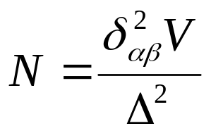
where
- N is the total sample size to be accrued to the study,
- V is the average variability contributed by each subject to the estimate of the treatment effect θ (for each problem below, I provide the formula for V),
- δ_{αβ} is a “standardized alternative” which would allow a standardized one-sided level α hypothesis test to reject the null hypothesis with probability (power) β (note that many textbooks use notation in which the power is denoted 1-β), and
- Δ is some measure of the distance between the null and alternative hypotheses.

Often clinical trials are conducted with a stopping rule which allows early termination of the study on the basis of one or more interim analyses of the data. When such a “group sequential test” is to be used, the value of the standardized alternative δ_{αβ} must be found using special computer software. On the other hand, when a “fixed sample study” (i.e., one in which the data are analyzed only once) is to be conducted, the standardized alternative for a one-sided test is given by
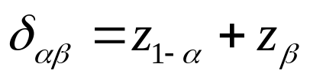
where z_{p} is the pth quantile of the standard normal distribution. For a two-sided level α test, the standardized alternative is given by
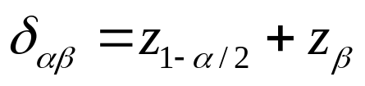
The value of z_{p} can be found from Stata, Excel, or R as described above.

The formula for Δ depends on the statistical model used, but is usually either
- Δ = θ₁ - θ₀ (used for inference in “additive models” for means and proportions, and sometimes medians), or
- Δ = log(θ₁ / θ₀) (used for inference in “multiplicative models” for geometric means, odds, and hazards, and sometimes means and medians),

- (Obtaining estimates for use in sample size calculations when using mean cholesterol) When making inference about cholesterol using means (and differences of means), the formula for V will typically involve the standard deviation σ of measurements made within a treatment group. The following estimates should be used as needed to answer all other questions. Using the inflamm.txt dataset available on the class web pages.
  - Ideally, we want the standard deviation of cholesterol at baseline and the standard deviation of cholesterol measured after two years of treatment. However, as we only have ready access to a single cross-sectional measurement, we will have to use that data to estimate both SDs. What is your best estimate of the standard deviation of cholesterol within the sample? Report using four significant digits.
Using STATA, we find that the estimate of the standard deviation of cholesterol within the sample is 39.29
  - Assuming that the correlation ρ of cholesterol measurements made two years apart on the same individual is ρ = 0.40, what is the standard deviation of the change in cholesterol measurements made after two years within the population? Report using four significant digits.
  - We could also consider an analysis that would adjust for age and sex. In such a setting, we would want an estimate of the SD within groups that are homogenous for age and sex. What is your best estimate of the standard deviation of cholesterol within groups that had constant age and sex? Report using four significant digits. (Hint: Recall that the output from a regression model will provide an estimate of a common SD within groups as the “root mean squared error”. So you will need to perform a regression that allows each age-sex combination to have its own mean. A linear regression modeling age continuously along with sex would be one approach.)
Using RMSE from linear regression adjusting for age and sex, we estimate the SD to be 37.49.
- (A two arm study of change in cholesterol after 2 years of treatment with adjustment for age and sex) Suppose we randomly assign N subjects to receive either the new treatment or a control strategy. We use a randomization ratio of 1 subject on the new treatment to 1 subject on control. We use as our measure of treatment effect the mean change in cholesterol at the end of treatment for patients on the new treatment and mean change in cholesterol at the end of treatment for patients on control. The null hypothesis is that the difference in means is 0 mg/dL, and we want to detect whether the new treatment will result in an average change in cholesterol that is 10 mg/dL lower than might be expected on control. We intend to perform a hypothesis test in which
- we adjust for age and sex,
- the one-sided level of significance is α = 0.025,
- the desired statistical power is β = 0.80 or 0.90,
- the measure of treatment effect is θ = (μ _{T,2} - μ _{T,0} ) – (μ _{C,2} - μ _{C,0} ) (the mean change in cholesterol in the patients receiving the new treatment for 2 years of treatment minus the mean change in cholesterol in the patients treated with control for two years), and
- the average variability contributed by each subject to the estimated treatment effect (the difference in sample means) is V= 8σ ²(1-ρ). (Again, use a correlation of 0.4.)
- the comparison between alternative and null hypotheses is Δ = θ₁ - θ₀.
- What sample size will provide 80% power to detect the design alternative?
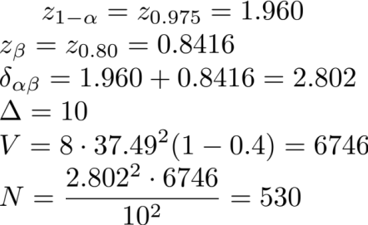
- What sample size will provide 90% power to detect the design alternative?
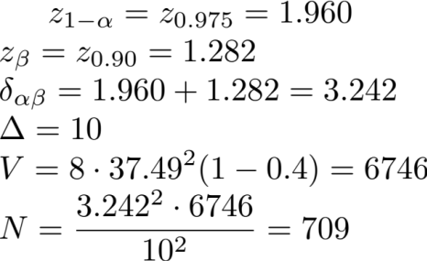
- How would the sample size for 90% power change if you had not decided to adjust for age and sex?
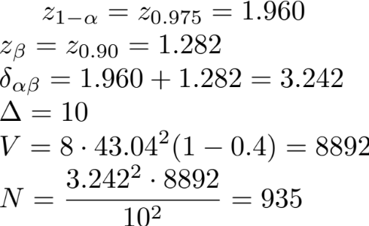
- What would be the effect on your sample size computation if you had decided to analyze only the final cholesterol measurement adjusted for age and sex (i.e., not the change)? (A qualitative answer is sufficient.)
We know that in a randomized clinical trial baseline cholesterol levels are the same. Since our correlation is small, measuring cholesterol adjusted for sex and age will give us smaller V, i.e. more precise, than including the baseline measurement. Therefore, the sample size would decrease.
- What would be the effect on your sample size computation if you had decided to use an Analysis of Covariance model that adjusted for age, sex, and the baseline cholesterol level? (A qualitative answer is sufficient.)
ANCOVA estimator is always the most efficient in the clinical trial setting, so the sample size would decrease.
- (A two arm study of cholesterol after 2 years of treatment and the effect of dichotomizing the data) Suppose we choose to provide the new treatment to N subjects. We use as our measure of treatment effect the proportion of subjects having cholesterol below 200 mg/dL at the end of treatment. We intend to perform a hypothesis test in which
- the one-sided level of significance is α = 0.025,
- the desired statistical power is β = 0.90,
- we presume that the proportion p_{C} of subjects on the control arm with serum cholesterol below 200 mg/dL will be the same as was observed in the CHS inflamm.txt data set.
- we presume that the treatment will tend to lower serum cholesterol by 10 mg/dL on average, so the proportion p_{T} of subjects on the treatment arm with serum cholesterol below 200 mg/dL will be the same as was observed in the CHS inflamm.txt data set for cholesterol levels below 210 mg/dL.
- the measure of treatment effect is θ₁ = p_{T,} - p_{C} (the difference in the proportion of subjects receiving the new treatment who have cholesterol lower than 200 mg/dL minus the corresponding proportion on the control arm after 2 years of treatment). Under the null hypothesis, we assume there would be no difference between the treatment arms.,
- the average variability contributed by each subject to the estimated treatment effect (the sample proportion) is V=2( p_{T,}(1- p_{T,} ) + p_{C} (1 - p_{C} ))(most often, we would compute this under the alternative hypothesis in this setting),
- the comparison between alternative and null hypotheses is Δ = θ₁ - θ₀ = θ₁.
- Using the inflammatory biomarkers dataset, what is your estimate of the proportion p_{C} of subjects on the control arm with serum cholesterol below 200 mg/dL at the end of treatment?
Using STATA, we find p_{C} to be 0.3919.
- Using the inflammatory biomarkers dataset, what is your estimate of the proportion p_{T} of subjects on the treatment arm with serum cholesterol below 200 mg/dL at the end of treatment? (This is assumed to be equal to the number having cholesterol levels below 210 mg/dL in the CHS data.)
Using STATA, we find p_{T} to be 0.4895.

- What sample size will provide 90% power to detect the design alternative?
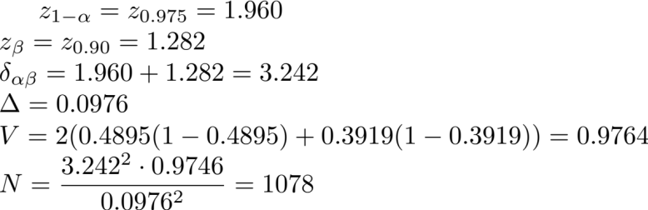

- What advantages or disadvantages does this study design have over the study design used in problem 4b?
This study requires a larger sample size and it answers a slightly different scientific question. If clinically it is more important to lower cholesterol level below 200 mg/dL, then this study is more relevant. If we are just interested in seeing if the drug lowers cholesterol level, we might choose the study design in problem 4b instead.
Discussion Sections: February 19 - 21, 2014

We begin discussion of the university salary dataset.

