HW 8
3/7/14

1a. Since degree and field are unordered categorical variables, the best way to model them would be to create dummy variables for each (both are three categories, so we need to create two dummy variables for each). Admin is binary, so leaving it as a binary variable is appropriate.

1b. Robust standard error is appropriate because one would expect heteroscedasticity in the data. In particular, there will likely be more variance in the higher salary values, where the data will be sparser. Thus, classical linear regression inference will tend to be anti-conservative.

1i. Dummy variables would not be a good choice since categorizing the continuous measures leads to loss of information. Quadratic would only be appropriate if there was an expected quadratic relationship with salary. Modeling the variables are continuous variables would be appropriate if the relationship with salary was expected to be linear, while using splines would be appropriate if a piecewise model was expected. In general, an a priori decision should be made based on what the expected relationship with salary will be.

2.
 | Estimate | Z | P value | 95% CI low | 95% CI high
A | -19.14 | -12.18 | <0.0001 | -22.22 | -16.06
B | 16.73 | 10.55 | <0.0001 | 13.62 | 19.84
C | -88.49 | -28.21 | <0.0001 | -94.63 | -82.34
D | 81.58 | 26.73 | <0.0001 | 75.60 | 87.57

2a. Mean monthly salary is $19.14 lower for each year increase in year of degree between two groups with similar degree, field, administrative duty, and sex (95% CI: $16.06 to $22.22 lower). These results are atypical of what we might expect with no true difference in mean monthly salary between year of degree groups with similar degree, field, administrative duty, and sex (p<0.0001).

2b. Mean monthly salary is $16.73 higher for each year increase in starting year between two groups with similar degree, field, administrative duty, and sex (95% CI: $13.62 to $19.84 higher). These results are atypical of what we might expect with no true difference in mean monthly salary between starting year groups with similar degree, field, administrative duty, and sex (p<0.0001).

2c. Mean monthly salary is $88.49 lower for each year increase in year of obtained degree between two groups with similar degree, field, administrative duty, sex, and starting year (95% CI: $82.34 to $94.63 lower). These results are atypical of what we might expect with no true difference in mean monthly salary between year of degree groups with similar starting year, degree, field, administrative duty, and sex (p<0.0001).

2d. Mean monthly salary is $81.58 higher for each year increase in starting year between two groups with similar degree, field, administrative duty, sex, and year of degree (95% CI: $75.60 to $87.57 higher). These results are atypical of what we might expect with no true difference in mean monthly salary between starting year groups with similar year of degree, degree, field, administrative duty, and sex (p<0.0001).

2e. If you compare a with c or b with d, you can see whether starting year and year of degree confounds the relationship between monthly salary with year of degree and starting salary, respectively, after adjusting for degree, field, administrative duty, and sex. Alternatively, you can see whether year of degree and starting year are associated with monthly salary after adjusting for degree, field, administrative duty, sex, and additionally starting year and year of degree respectively.

3. Difference in means
 | Estimate | Z statistic | P value | 95% CI low | 95% CI high
A | -1335 | -14.04 | <0.0001 | -1521 | -1148
B | -1266 | -13.40 | <0.0001 | -1452 | -1081
C | -614.1 | -7.17 | <0.0001 | -782.2 | -446.0
D | -614.6 | -7.06 | <0.0001 | -785.3 | -443.8
E | -420.0 | -5.05 | <0.0001 | -583.1 | -257.0
F | -419.7 | -5.17 | <0.0001 | -579.0 | -260.5
G | -280.7 | -4.08 | <0.0001 | -415.5 | -145.8

4. Ratio of geometric means
 | Estimate | Z statistic | P value | 95% CI low | 95% CI high
A | 0.8120 | -13.73 | <0.0001 | 0.7882 | 0.8365
B | 0.8204 | -13.09 | <0.0001 | 0.7964 | 0.8451
C | 0.9090 | -6.99 | <0.0001 | 0.8850 | 0.9337
D | 0.9087 | -6.98 | <0.0001 | 0.8845 | 0.9335
E | 0.9362 | -5.06 | <0.0001 | 0.9126 | 0.9605
F | 0.9363 | -5.17 | <0.0001 | 0.9132 | 0.9600
G | 0.9574 | -4.08 | <0.0001 | 0.9376 | 0.9776

5. Ratio of means (GLM)
 | Estimate | Z statistic | P value | 95% CI low | 95% CI high
A | 0.8017 | -13.58 | <0.0001 | 0.7765 | 0.8277
B | 0.8097 | -12.99 | <0.0001 | 0.7844 | 0.8359
C | 0.8981 | -7.12 | <0.0001 | 0.8719 | 0.9251
D | 0.8964 | -7.04 | <0.0001 | 0.8695 | 0.9241
E | 0.9251 | -5.26 | <0.0001 | 0.8986 | 0.9524
F | 0.9245 | -5.49 | <0.0001 | 0.8989 | 0.9508
G | 0.9507 | -4.15 | <0.0001 | 0.9283 | 0.9736

6.
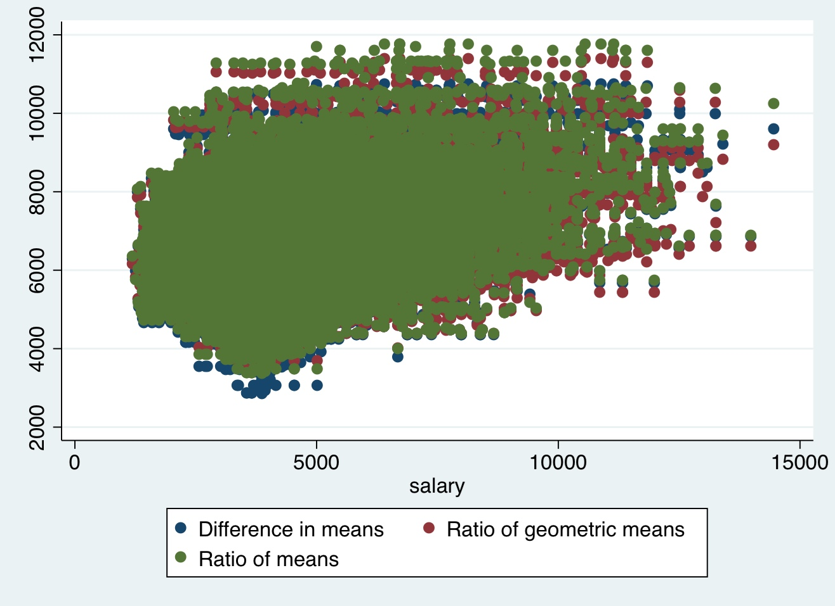

Predicted values for 4 and 5 used ratios of salary where as 3 used differences between males and females. 3 and 5 used mean salary while 4 used geometric mean salary. The predicated values from the three models are very close to one another, so the inference would be fairly comparable across the three.

7. The three models are fairly similar, so I would choose the model looking at difference in means.
Methods: Data of faculty members’ monthly salary at the University of Washington were collected from 1597 faculty members in 1995. The difference in mean monthly salary been females and males was calculated using linear regression. Confidence intervals and two-sided p-values were compared using Wald statistics based on the Huber-White sandwich estimator. Several models were calculated, including an unadjusted model and models adjusted on highest degree attained (PhD, professional, other), year of degree (modeled as linear splines with knots at 1960, 1965, 1970, 1975, 1980, 1985, 1990), starting year at UW (modeled as linear splines with knots at 1960, 1965, 1970, 1975, 1980, 1985, 1990), field of study (arts, professional, other), administrative duty (yes/no), and rank (Assistant, Associate, Full).
Results: The following table presents the models looking at the difference in mean monthly salary between females and males adjusted for variables in column 1.

 | Estimate | Z statistic | P value | 95% CI low | 95% CI high
Unadjusted | -1335 | -14.04 | <0.0001 | -1521 | -1148
Degree | -1266 | -13.40 | <0.0001 | -1452 | -1081
Degree, year of degree | -614.1 | -7.17 | <0.0001 | -782.2 | -446.0
Degree, year of degree, starting year at UW | -614.6 | -7.06 | <0.0001 | -785.3 | -443.8
Degree, year of degree, starting year at UW, field | -420.0 | -5.05 | <0.0001 | -583.1 | -257.0
Degree, year of degree, starting year at UW, field, administrative duty | -419.7 | -5.17 | <0.0001 | -579.0 | -260.5
Degree, year of degree, starting year at UW, field, administrative duty, rank | -280.7 | -4.08 | <0.0001 | -415.5 | -145.8

Interpretations:
Unadjusted: The mean monthly salary is $1335 lower for women compared to men (95% CI: 1148 to 1521 lower), which is highly atypical of what we might expect if there were no true difference in mean monthly salary between women and men (p<0.0001).
Degree adjusted: The mean monthly salary is $1266 lower for women compared to men with similar degree (95% CI: 1081 to 1452 lower), which is highly atypical of what we might expect if there were no true difference in mean monthly salary between women and men with similar degree (p<0.0001).
Degree and year of degree adjusted: The mean monthly salary is $614.1 lower for women compared to men with similar degree and year of degree (95% CI: 446.0 to 782.2 lower), which is highly atypical of what we might expect if there were no true difference in mean monthly salary between women and men with similar degree and year of degree (p<0.0001).
Degree, year of degree, starting year at UW adjusted: The mean monthly salary is $614.6 lower for women compared to men with similar degree, year of degree, and start year at UW (95% CI: 443.8 to 785.3 lower), which is highly atypical of what we might expect if there were no true difference in mean monthly salary between women and men with similar degree, year of degree, and start year at UW (p<0.0001).
Degree, year of degree, starting year at UW, field adjusted: The mean monthly salary is $420.0 lower for women compared to men with similar degree, year of degree, start year at UW, and field (95% CI: 257.0 to 583.1 lower), which is highly atypical of what we might expect if there were no true difference in mean monthly salary between women and men with similar degree, year of degree, start year at UW, and field (p<0.0001).
Degree, year of degree, starting year at UW, field, administrative duty adjusted: The mean monthly salary is $419.7 lower for women compared to men with similar degree, year of degree, start year at UW, field, and administrative duty (95% CI: 260.5 to 579.0 lower), which is highly atypical of what we might expect if there were no true difference in mean monthly salary between women and men with similar degree, year of degree, start year at UW, field, and administrative duty (p<0.0001).
Degree, year of degree, starting year at UW, field, administrative duty, rank adjusted: The mean monthly salary is $280.7 lower for women compared to men with similar degree, year of degree, start year at UW, field, administrative duty, and rank (95% CI: 145.8 to 415.5 lower), which is highly atypical of what we might expect if there were no true difference in mean monthly salary between women and men with similar degree, year of degree, start year at UW, field, administrative duty, and rank (p<0.0001).
There was a significant difference in mean monthly salary between men and women employed at UW in 1995 across all of our models, suggesting that there was discrimination against women in awarding salaries at UW in 1995.

