Biost 518: Applied Biostatistics II
Biost 515: Biostatistics II
Emerson, Winter 2015

Homework #4
February 2, 2015

This homework investigates associations between death from any cause and age, sex, and serum bilirubin in a population of patients with primary biliary cirrhosis who were enrolled in a randomized clinical trial (RCT) of D-penicillamine. The data can be found on the class web page (follow the link to Datasets) in the file labeled liver.txt. Documentation is in the file liver.doc.

- Provide suitable descriptive statistics pertinent to the scientific questions addressed in this homework.
Methods: Descriptive statistics were tabulated for the sample overall and by age group, sex, and serum bilirubin level. Age was categorized in 10-year age groups within the range of ages in the sample. The minimum age was 26.3 years and the maximum was 78.4. Accordingly, age was categorized as 25 to 34.9, 35 to 44.9, 45 to 54.9, 55 to 64.9, and 65 and up. One hundred and six participants (25.4%) had missing data on sex; to describe the survival among these subjects, they were analyzed as a separate category. As serum bilirubin is hypothesized to have a multiplicative association with risk of death, it was categorized into groups corresponding roughly to a doubling in levels, starting from the normal range of 0.3 to 1.1 mg/dl. The baseline distribution of these variables was described by tabulating the proportion of the sample in each group. For the sample overall and for strata defined by the variable categories, Kaplan-Meier survival estimates were calculated for the 5 and 10-year survival probabilities, the 20th percentile of time to death and the median. Observation time was divided by 365.342 to convert it from days to years. Kaplan-Meier survival curves were also graphed for strata defined by each variable.
Results: Data on risk factors and survival were collected on 418 patients with primary biliary cirrhosis (PBC). In the study period, 161 of these patients were observed to die from any cause (Table 1). Among all subjects, the median survival time was 9.30 years and the 20th percentile of time to death was 3.15 years. Seventy percent (70.3%) survived up to 5 years, and 44.2% survived up to 10 years from the start of the study observation period. The modal age group was 45 to 54 years old (33.3% of participants), with 24.2% of the sample falling in the 35 to 44 year age group and 25.8% in the 55 to 64 year age group. The minimum age was 26.3 and the maximum was 78.4 years. The median survival time decreased with each age group, although those in the 55 to 65 year age group had slightly higher median survival (9.43 years) than those in the 45 to 54 year age group (8.68 years). The 20th percentile and the 5 and 10-year survival probabilities matched this trend. The survival curves by age group are presented in Figure 1. The vast majority of patients were female (66.0%), reflecting the tendency for the disease to affect women more than men. A quarter of the sample (25.4%) had missing data on sex, however (Table 1). These were likely the 106 patients who were not randomized into the trial on D-penicillamine. Females and those with missing data had longer median survival times (9.39 years among females, 9.75 years among those missing, and 6.53 years among men). Females and those with missing data also had higher probability of surviving to 5 and 10 years as well (Figure 2). By serum bilirubin level, the probability of survival decreased for each doubling of serum bilirubin (Table 1; Figure 3). Forty two percent (42.3%) of the sample had serum bilirubin levels in the normal range of 0.3 to 1.1 mg/dl. The median survival time among this group could not be estimated from the data, as only 28 of the 177 were observed to die. However, 93.8% survived to 5 years and 72.0% to 10-years, and the 20th percentile of time to death was 7.58 years. For comparison, 77.9% of those with bilirubin levels between 1.2 and 2.2 mg/dl survived to 5 years, 47.1% to 10 years, and the 20th percentile was 4.42 years. This decreased to 12.5% survival at 5 years among those with bilirubin between 17.7 and 35.2 mg/dl, among whom the 20th percentile of time to death was only 0.211 years.
Table 1: Baseline distribution and survival probability among 418 patients with primary biliary cirrhosis (PBC), overall and by age group, sex, and serum bilirubin level
 | Baseline  Distribution  % (n/N) | Survival (time to death)
 | Baseline  Distribution  % (n/N) | 5 yr survival probabilityª | 10yr survival probabilityª | 20th percentileª | Medianª | n deaths /  n subjects
All subjects | 100. (418/418) | 70.3% | 44.2% | 3.15 years | 9.30 years | 161 / 418
Age (years)
25 – 34 | 7.18 (30/418) | 92.2% | 75.9% | 7.36 years | NAª | 4 / 30
35 – 44 | 24.2 (101/418) | 80.5% | 60.2% | 5.76 years | 11.2 years | 25 / 101
45 – 54 | 33.3 (139/418) | 67.6% | 40.7% | 2.26 years | 8.68 years | 64 / 139
55 – 64 | 25.8 (108/418) | 68.4% | 43.2% | 2.74 years | 9.43 years | 42 / 108
65 and up | 9.57 (40/418) | 43.6% | NAª | 1.67 years | 4.42 years | 26 / 40
Sex
Male | 8.61 (36/418) | 52.2% | 34.3% | 2.74 years | 6.53 years | 22 / 36
Female | 66.0 (27/418) | 73.5% | 44.9% | 3.38 years | 9.39 years | 103 / 276
Missing | 25.4 (106/418) | 67.8% | 41.9% | 2.71 years | 9.75 years | 36 / 106
Bilirubin (mg/dl)
0.3 – 1.1 | 42.3 (177/418) | 93.8% | 72.0% | 7.58 years | NAª | 28 / 177
1.2 – 2.2 | 22.0 (92/418) | 77.9% | 47.1% | 4.42 years | 9.75 years | 32 / 92
2.3 – 4.4 | 15.1 (63/418) | 46.6% | NAª | 2.11 years | 4.63 years | 38 / 63
4.5 – 8.8 | 12.0 (50/418) | 38.6% | 12.9% | 1.34 years | 3.91 years | 31 / 50
8.9 – 17.6 | 6.70 (28/418) | 14.3% | NAª | 0.359 years | 2.01 years | 25 / 28
17.7 – 35.2 | 1.91 (8/418) | 12.5% | NAª | 0.211 years | 2.34 years | 7 / 8
ª Based on Kaplan-Meier survival estimates. NA indicates that the survival function at the specified point could not be estimated with the data available.

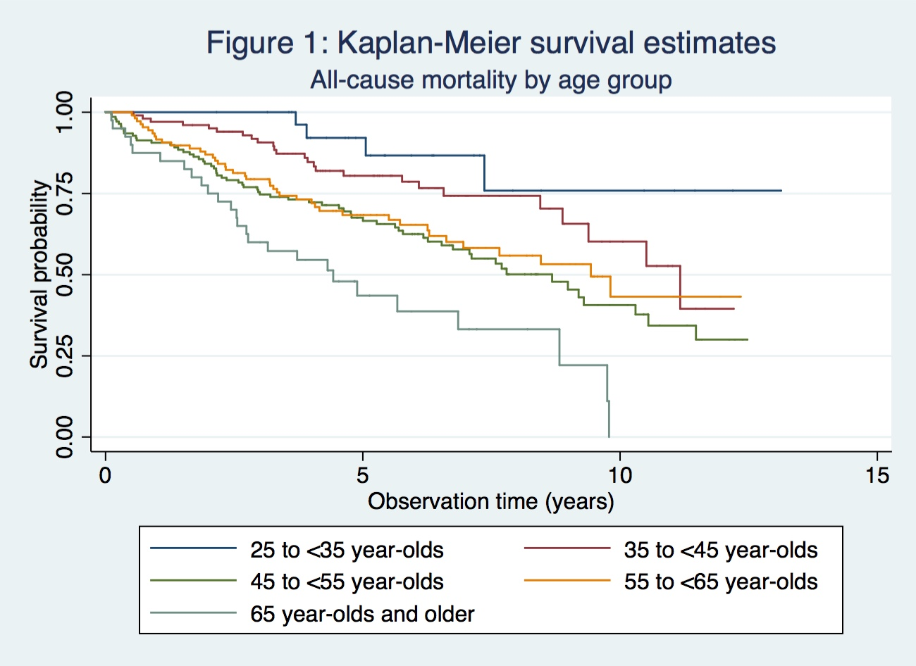
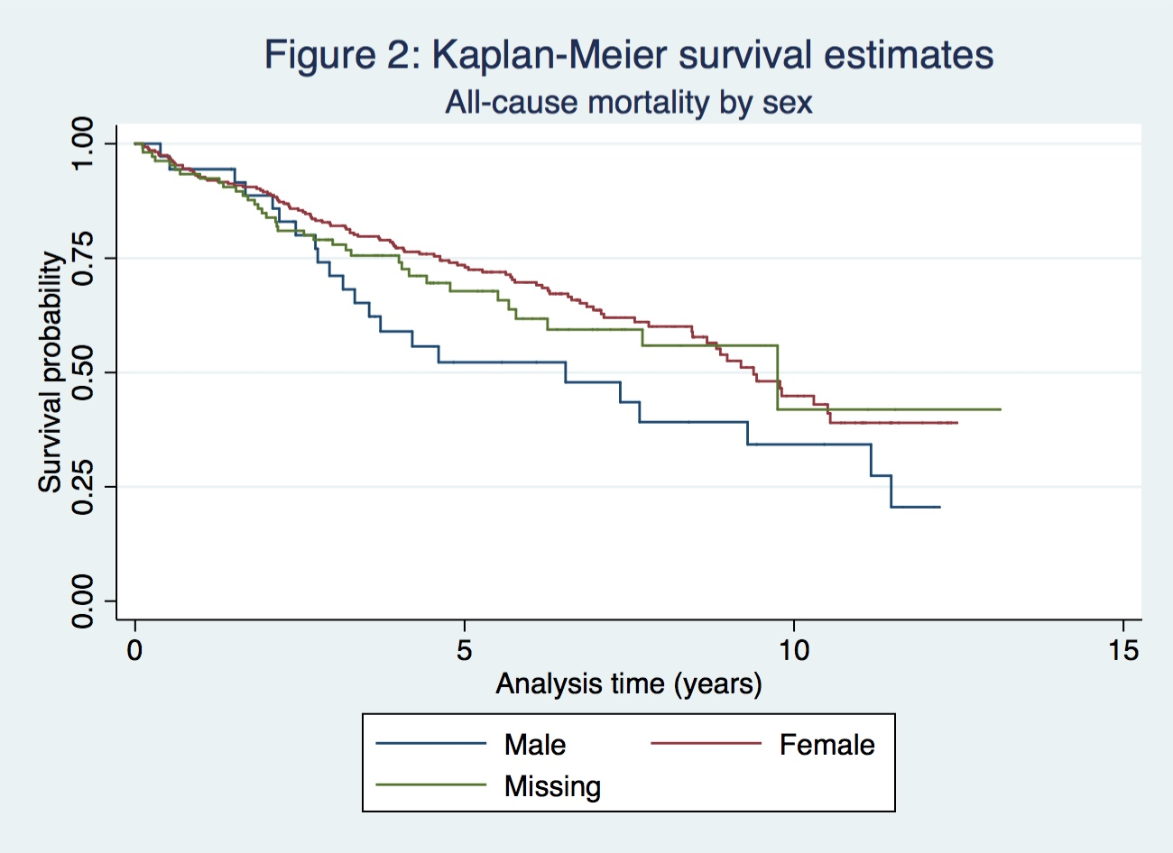
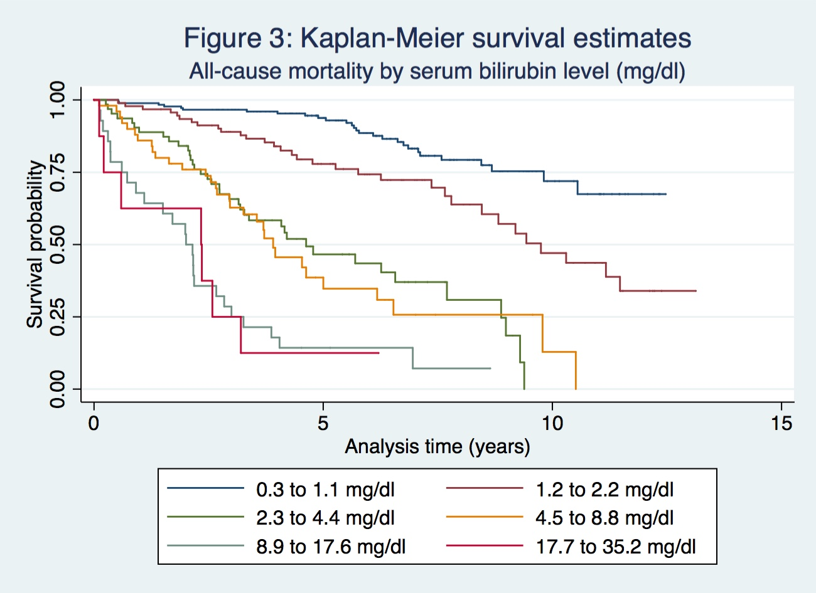

- In prior homeworks using the Cardiovascular Health Study datasets, we were able to use logistic regression to investigate associations between mortality and various covariates. Why might such an approach not seem advisable with these data? (Consider the extent to which such analyses might be confounded and/or lack precision.)
For these analyses, we restricted to the observation time to look at mortality within four years, at which point no censoring events had occurred. In this case, however, the first censored observation was at 1.46 years, and right-censored data cannot be accurately analyzed using logistic regression. Restricting the analysis to look at death before this period would be very inefficient, as it would ignore variation in survival in the majority of the observation period, from 1.46 to 13 years. And analyzing the data from the full period with logistic regression would misclassify censored observations as survivors. Although we assume noninformative censoring for survival analyses, if censored observations were coded as non-deaths, censoring would be associated with the outcome. If the probability of being censored were also associated with age, sex, or bilirubin level, this would introduce confounding. If not, this would reduce precision in the estimates of associations with mortality, since censored observations would still be misclassified as non-deaths.
- Perform a statistical regression analysis evaluating an association between serum bilirubin and all-cause mortality by comparing the instantaneous risk (hazard) of death over the entire period of observation across groups defined by serum bilirubin modeled as a continuous variable.
  - Include a full report of your inference about the association.
Methods: A proportional hazards regression model was fit to the data to examine the association between serum bilirubin and death from any cause among 418 patients with primary biliary cirrhosis (PBC). Serum bilirubin was modeled as a continuous variable, and standard errors were calculated using robust estimates to relax the assumptions of proportional hazards and linearity in the predictor. None of the observations had missing data on bilirubin. The null hypothesis that the risk of death is equivalent across levels of bilirubin (hazard ratio (HR)=1) is tested with α=0.05. In addition to a two-sided p-value corresponding to the hypothesis test, a point estimate of the hazard ratio and 95% confidence intervals are presented to examine the strength and precision of the association.
Results: From simple proportion hazards regression on 418 PBC patients, we estimate that for each 1 mg/dl increase in serum bilirubin, the risk of death is 15.2% higher in the group with the higher level of bilirubin (HR=1.15). Based on a 95% confidence interval, this result is consistent with a risk of death between 12.1% and 18.5% higher for every 1 unit increase in bilirubin. This result is statistically significant (p<0.0001), suggesting that we should reject the null hypothesis in favor of a hypothesis that the risk of death is not equal between groups with different levels of serum bilirubin.
  - For each population defined by serum bilirubin value, compute the hazard ratio relative to a group having serum bilirubin of 1 mg/dL. (This will be used in problem 6). If HR is the hazard ratio (use the actual hazard ratio estimate) obtained from your regression model, this can be effected by the Stata code
gen fithrA = HR ^ (bili – 1)
It could also be computed by creating a centered bilirubin variable, and then using the Stata predict command
gen cbili = bili – 1
stcox cbili
predict fithrA
Methods: Using post-estimation from the simple proportional hazards model on serum bilirubin and risk of death from all causes, the hazard ratio for each level of serum bilirubin relative to 1 mg/dL was estimated.
Results: See problem 6.
- Perform a statistical regression analysis evaluating an association between serum bilirubin and all-cause mortality by comparing the instantaneous risk (hazard) of death over the entire period of observation across groups defined by serum bilirubin modeled as a continuous logarithmically transformed variable.
  - Why might this analysis be preferred a priori?
This analysis might be preferred because the association between bilirubin concentration and increased risk of death is unlikely to be linear – the increase in the risk of death for a bilirubin level elevated 1 mg/dL from normal/healthy levels is unlikely to remain constant for every subsequent unit increase in bilirubin. If it did, those with bilirubin levels of 28 mg/dl would have a high probability of dying any second. This suggests that the data generation mechanism is multiplicative and it is more scientifically sound to model serum bilirubin as a logarithmically transformed variable.
  - Include a full report of your inference about the association.
Methods: A simple proportional hazards regression model was fit to the data to examine the association between serum bilirubin and death from any cause among 418 patients with primary biliary cirrhosis (PBC). Serum bilirubin was modeled as a logarithmically transformed variable with log base 2 to examine the risk of death associated with a doubling in serum bilirubin. Standard errors were calculated using robust estimates to relax the assumptions of proportional hazards and linearity in the predictor. None of the observations had missing data on bilirubin. The null hypothesis that the risk of death is constant across levels of bilirubin (hazard ratio (HR)=1) is tested with α=0.05. In addition to a two-sided p-value corresponding to the hypothesis test, a point estimate of the hazard ratio and 95% confidence intervals are presented to examine the strength and precision of the association.
Results: From simple proportion hazards regression on 418 PBC patients, we estimate that the risk of death from any cause increases by 98.4% for each two-fold increase in serum bilirubin levels (HR=1.98). Based on a 95% confidence interval, this result is consistent with an increase in the risk of death by a factor of 1.78 to 2.21 for every two-fold increase in serum bilirubin. This result is highly statistically significant (p<0.0001), suggesting that we should reject the null hypothesis in favor of a hypothesis that the risk of death is not constant across levels of bilirubin.
  - For each population defined by serum bilirubin value, compute the hazard ratio relative to a group having serum LDL of 1 mg/dL. (This will be used in problem 6). If HR is the hazard ratio (use the actual hazard ratio estimate) obtained from your regression model, this can be effected by the Stata code
gen logbili = log(bili)
stcox logbili
fithrB = HR ^ (logbili)
(Note that the log(1) = 0 when using any base, so there is no need to rescale by the bilirubin values. Note also that you might want to use a different base in your logarithmic transformation in order to facilitate more natural reporting of effects.)
Methods: Using the hazard ratio estimated from simple proportional hazards regression on the risk of death associated with log base 2 transformed serum bilirubin, hazard ratios for each observed level of serum bilirubin relative to a group with serum bilirubin of 1 mg/dL were estimated by taking the model estimate to the power of the log₂-transformed bilirubin value.
Results: See problem 6.
- One approach to testing to see whether an association between the response and the predictor of interest is adequately modeled by an untransformed continuous variable is to add some other transformation to the model and see if that added covariate provides statistically significant improved “fit” of the data. In this case, we could test for “linearity” of the bilirubin association with the log hazard ratio by including both the untransformed and log transformed bilirubin. (Other alternatives might have been bilirubin and bilirubin squared, but in this case our a priori interest in the log bilirubin might drive us to the specified analysis.)
  - Provide full inference related to the question of whether the association is linear.
Methods: A proportional hazards regression model was fit to the data to assess the linearity of the association between serum bilirubin and death from any cause among 418 patients with primary biliary cirrhosis (PBC). The predictor of interest is serum bilirubin measured as an untransformed continuous variable. Additionally, logarithmically transformed (log base 2) serum bilirubin was entered into the model as a covariate. The change in the fit of the model was examined to determine if the untransformed continuous variable adequately modeled the association between serum bilirubin and death from any cause. None of the observations had missing data on bilirubin, and standard errors were calculated using robust estimates to relax the assumptions of proportional hazards and linearity in the predictor. In addition to a two-sided p-value, a point estimate of the hazard ratio and 95% confidence intervals are presented to examine the strength and precision of the association between untransformed serum bilirubin and death from any cause.
Results: From proportion hazards regression assessing the association between all-cause mortality serum bilirubin adjusting for logarithmically transformed serum bilirubin, a one-unit increase in serum bilirubin was associated with a 3.86% relative reduction in the risk of death. However, this estimate would not be surprising if the true risk of death decreased by as much as 8.85% or increased by as much as 1.41%. This result is not statistically significant (p=0.148), and we cannot reject the null hypothesis that there is no difference in the relative risk of death for a one-unit increase in bilirubin when adjusting for logarithmically transformed serum bilirubin. In contrast, when serum bilirubin is modeled only as a continuous variable in a simple proportional hazards regression, the estimated hazard ratio associated with a one-unit increase in serum bilirubin is 1.15 (95% CI 1.12, 1.18). The change in this estimate from significant (p<0.0001) to non-siginificant (p=0.148) with the addition of the logarithmically transformed variable suggests that the continuous predictor does not adequately model the relationship. Furthermore, the model fit is improved with the addition of the logarithmically transformed variable: the Wald chi-square statistic increases from 100.63 to 142.12.
  - Again, save the fitted values from this model by obtaining the estimated HRs relative to a group with bilirubin of 1 mg/dl. (This will be used in problem 6.)
Methods: To estimate the hazard ratio for each observed value of bilirubin relative to those with a level of 1 mg/dL, the model estimate of the hazard ratio corresponding to a one-unit increase in serum bilirubin, adjusting for log transformed serum bilirubin, was exponentiated to the power of the bilirubin value minus 1.
Results: See problem 6.
- Display a graph with the fitted hazard ratios from problems 3 - 5. Comment on any similarities or differences of the fitted values from the three models.
Methods: Methods for the estimation of hazard ratios are described in problems 3-5 part c. Estimates of the hazard ratios for risk of death among those with each observed serum bilirubin level relative to the group with 1 mg/dL bilirubin from each regression model were plotted on a scatter plot.
Results: The estimates for hazard ratios based on the simple proportional hazards regression model on untransformed continuous bilirubin increase exponentially with every unit increase in serum bilirubin. The hazard ratios are relatively low up to a bilirubin level of 10, at which point the hazard ratios increase dramatically, reaching levels suggestive of a risk of death among those with bilirubin levels of 28 mg/dL that are 50 times as high as the risk of death among those with bilirubin levels of 1 mg/dL. These data indicate that the estimates based on the untransformed predictor do not model a linear relationship between serum bilirubin and risk of death. In contrast, the estimates for hazard ratios based on the simple proportional hazards regression model on logarithmically transformed bilirubin (log base 2) increase linearly with the predictor. These estimates increase steadily from the other two estimates with a constant, positive slope. While the estimates of the hazard ratios associated with continuous bilirubin obtained from the model that adjusts for the logarithmically transformed bilirubin are also linear across levels of bilirubin, the line has a slope very close to zero. This provides further evidence that the continuous, untransformed variable does not fit the data well. The logarithmically transformed predictor seems to have the best fit and is most appropriate for use in proportional hazards regression, as it produces hazard ratios that are linear across groups in the predictor.

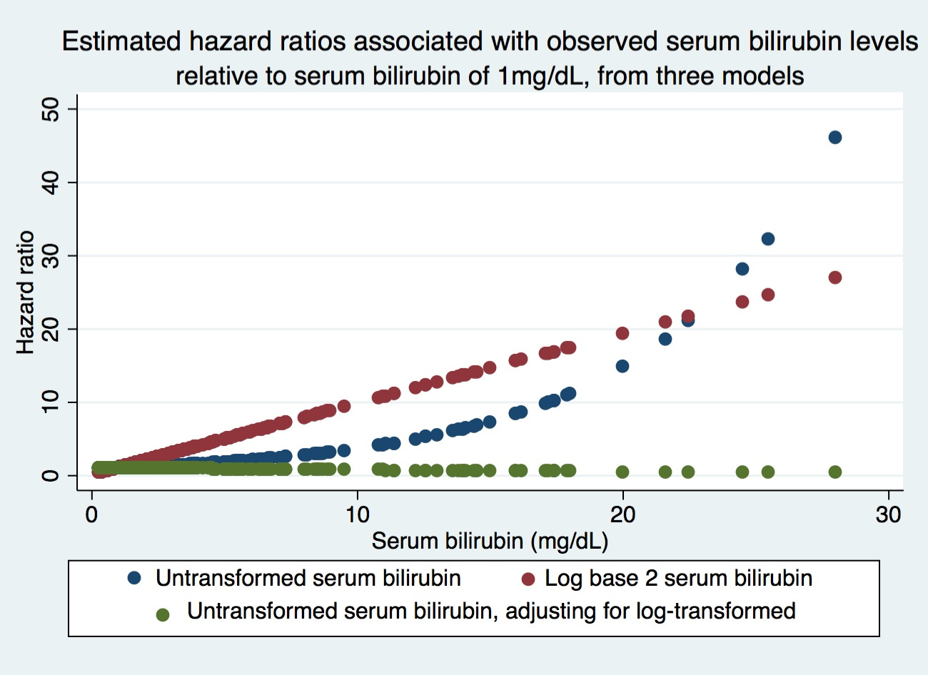
- We are interested in considering analyses of the association between all cause mortality and serum bilirubin after adjustment for age and sex.
  - What evidence is present in the data that would make you think that either sex or age might have confounded the association between death and bilirubin? (In real life, we would ideally decide whether to adjust for potential confounding in our pre-specified statistical analysis plan (SAP)).
The data presented in Table 1 indicate that age is associated with survival, which aligns with what we would expect. We know that the likelihood of diagnosis with PBC is highest starting around age 35, and those who are older are likely to have had the disease longer and may have other health complications due to old age. Consequently, we can assume a causal association between age and survival. However, there does not appear to be much of an association between bilirubin and age in the data. Although statistical significance is not relevant here, the data do not suggest any trend in bilirubin with age, which is required for the variable to be considered a confounder.
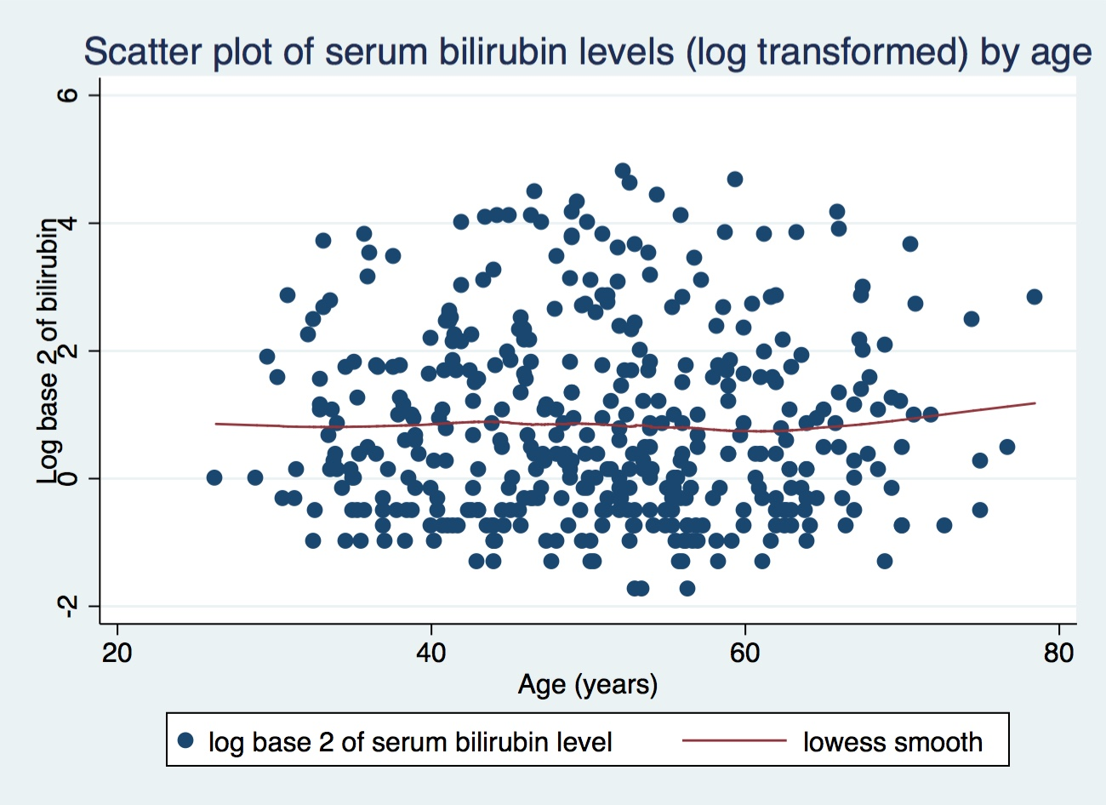
The data in Table 1 also indicate that sex is associated with survival, with females having a higher probability of survival (lower probability of death from any cause). We know that sex is associated with likelihood of developing PBC, and we might expect that there would be differences in mortality by sex among those who do develop it – perhaps the men who do develop the disease are more likely to be in poorer health overall. There is also evidence in the data that sex is associated with serum bilirubin level. Among women, the mean serum bilirubin is 3.31 mg/dL (SD 4.75; min 0.3, max 28), compared to a mean of 2.87 mg/dL among men (SD 2.23; min 0.6, max 8.6). The median among women, however, is lower than among men at 1.3 mg/dL compared to 2.2 mg/dL. This reflects the fact that this distribution is highly skewed, with more observations at very high levels of serum bilirubin than men, despite the fact that most of the sample had very low levels. Although these parameters do not give a consistent picture for how bilirubin differs by sex, the data suggest that there are differences in serum bilirubin by sex. Since sex is not in the casual pathway from bilirubin to death (bilirubin level does not cause sex), it is a potential confounder.
  - What evidence is present in the data that would make you think that either sex or age might have added precision to the analysis of the association between death and bilirubin? (In real life, we would ideally decide whether to adjust in our pre-specified SAP).
As shown in Table 1 and Figure 1, age and sex are both associated with all-cause mortaitily in the sample; the risk of death increases with age and is higher among females. Age does not appear to be associated with bilirubin in the sample, so adjusting for it would add precision to the estimate of the association between death and bilirubin. Although there are some differences in bilirubin by sex, sex may just be a precision variable and not a confounder. Because of the association between sex and risk of death, adjusting for sex would be expected to add precision to the analysis as well.
  - Provide full inference regarding an association between death and bilirubin after adjustment for sex and age.
Methods: A multivariable proportional hazards regression model was fit to the data to examine the association between serum bilirubin and death from any cause among 418 patients with primary biliary cirrhosis (PBC), adjusting for age and sex. Serum bilirubin was modeled as a logarithmically transformed variable with log base 2 to examine the risk of death associated with a doubling in serum bilirubin. Age was modeled as a continuous variable, and sex was modeled as a binary indicator variable. One hundred and six subjects with missing data on sex were excluded from analsis. Standard errors were calculated using robust estimates to relax the assumptions of proportional hazards and linearity in the predictor. The null hypothesis that the risk of death is constant across a two-fold increase in bilirubin (hazard ratio (HR)=1) while adjusting for age and sex is tested with α=0.05. In addition to a two-sided p-value corresponding to the hypothesis test, a point estimate of the adjusted hazard ratio and 95% confidence intervals are presented to examine the strength and precision of the association.
Results: From multivariable proportion hazards regression on 312 PBC patients, we estimate that, for each doubling in serum bilirubin, the risk of death from any cause is 2.11 times as high in the group with higher serum bilirubin levels (HR 2.11). Based on a 95% confidence interval, this result is consistent with a true increase in the risk of death by a factor of 1.84 to 2.42 for every two-fold increase in serum bilirubin, controlling for age and sex. This result is highly statistically significant (p<0.0001), suggesting that we should reject the null hypothesis in favor of a hypothesis that the risk of death is not constant across levels of bilirubin when adjusting for age and sex.
- Note that in the above analyses, we completely ignored the intervention in the RCT? What impact could this have had on our results?
I would expect that the intervention would modify the effect of bilirubin on death, such that among those who received D-penicillamine, the hazard ratio would be lower for increases in bilirubin than it would among those who received the placebo or were not enrolled in the trial. If we assume that there was no association between being selected into the trial and serum bilirubin and that randomization was done well, participation in the trial would not be associated with the predictor of interest. In that case, the analyses we did would approximate a weighted average of the stratum-specific effects across stratum defined by intervention status.
If there association between bilirubin and death is not modified by intervention status, I would expect intevention status to be a precision variable, such that controlling for it would improve the precision of our results.

