Biost 515 Homework 4

1. Methods: Descriptive statistics are provided for 418 subjects who were all PBC positive and enrolled in a randomized clinical trial of d-penicillamine conducted by the Mayo Clinic. Since our information includes censored observations, descriptive statistics are based on Kaplan-Meier estimates. Included below are the minimum and maximum censoring times and the estimated mean follow up time. We also provide descriptive statistics based on Kaplan- Meier estimates stratified on age, sex and bilirubin count separately to explore the association between death from any cause and age (3 ranges; >25 and <40, >=40 and <65, >=65), sex (M or F) and bilirubin level in mg/dL (4 ranges; <=1, >1 and <=2, >2 and <=4, >4). Within the samples defined by stratification, we provide estimates of 1, 2, 4, 6, 8 and 10 year survival probabilities and survival curves.

Results: The study included 418 subjects who were all positive for PBC and enrolled in the Mayo Clinical Trial. Of those, none were missing data for age or bilirubin level. However, 106 subjects were missing information for sex. These 106 subjects were removed only from the analysis stratified on sex. The 418 subjects were followed for death from any cause for a Kaplan-Meier estimated mean 5.255 years (median of 4.740 years; range .112 years to 13.137 years). The minimum censoring time was 1.460 years and the maximum censoring time was 13.137 years. During the study 161 of these subjects were observed to die. Of the 312 subjects for which we have data on sex, 88.5% were female. For the 418 subjects for which we had data on bilirubin count and age, the mean bilirubin count was 3.22 (SD 4.41, range 0.3 to 28) and the mean age was 50.7 (SD 10.45, range 26.3 to 78.4).

The tables below present estimates of the survival distribution within strata defined by bilirubin count (Table 1), age (Table 2), and sex (Table 3) with each table also presenting estimates of the total sample. Also included below are Kaplan-Meier Curves for each strata. As you can see from the tables and survival curves presented below, probability of survival is negatively associated with higher bilirubin levels, older ages and being male. Notice however that most of our subjects are female which may indicate that being PBC positive is more likely in females.

Table 1
Bilirubin (mg/dL) Level at Time of Study Enrollment
 | <=1 | >1 and <=2 | >2 and <=4 | >4 | All Subjects
N Subjects | 157 | 99 | 73 | 89 | 418
N Deaths | 22 | 32 | 42 | 65 | 161
1-year Survival Probability | 99.4% | 97.0% | 90.4% | 78.7% | 92.8%
2-year Survival Probability | 96.8% | 93.9% | 84.9% | 68.5% | 88.0%
4-year Survival Probability | 96.1% | 85.0% | 66.2% | 32.6% | 75.2%
6-year Survival Probability | 89.7% | 75.7% | 50.0% | 25.4% | 66.4%
8-year Survival Probability | 82.2% | 61.5% | 40.1% | 17.4% | 56.9%
10-year Survival Probability | 75.9% | 48.1% | 10.7% | 8.7% | 44.2%

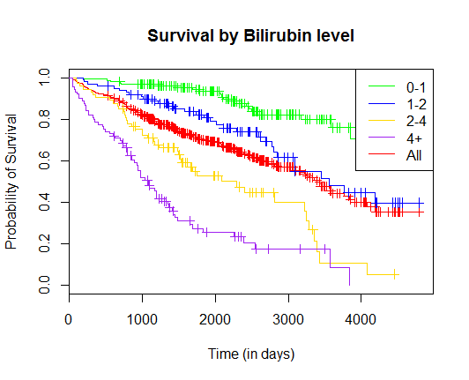
Table 2
Age at Time of Study Enrollment
 | >25 and <40 | >= 40 and <65 | >= 65 | All Subjects
N Subjects | 69 | 309 | 40 | 418
N Deaths | 13 | 122 | 26 | 161
1-year Survival Probability | 98.6% | 92.2% | 87.5% | 92.8%
2-year Survival Probability | 98.6% | 87.4% | 75.0% | 88.0%
4-year Survival Probability | 86.4% | 75.3% | 54.5% | 75.2%
6-year Survival Probability | 80.3% | 66.9% | 38.7% | 66.4%
8-year Survival Probability | 74.1% | 56.6% | 33.2% | 56.9%
10-year Survival Probability | 57.7% | 47.1% | 0.0% | 44.2%

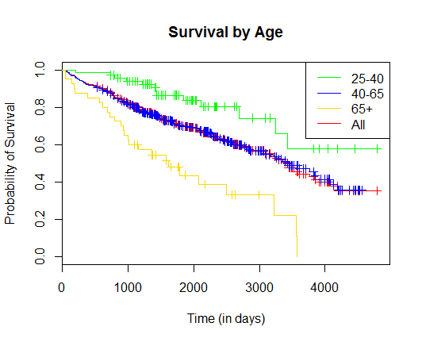

Table 3
Subjects by Sex
 | Male | Female | All Subjects
N Subjects | 36 | 276 | 312
N Deaths | 22 | 103 | 125
1-year Survival Probability | 94.4% | 92.8% | 92.9%
2-year Survival Probability | 88.7% | 89.5% | 89.4%
4-year Survival Probability | 59.0% | 77.2% | 75.2%
6-year Survival Probability | 52.2% | 69.7% | 67.7%
8-year Survival Probability | 39.2% | 60.1% | 57.3%
10-year Survival Probability | 34.3% | 44.9% | 43.9%

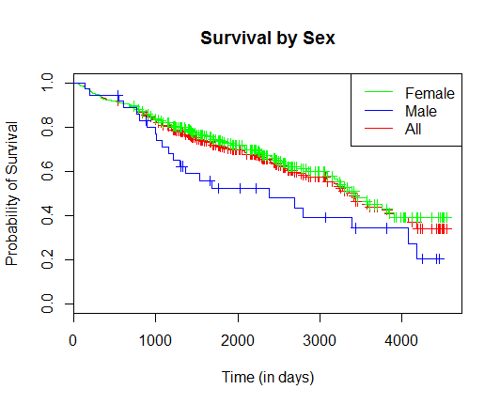

2. In logistic regression, we would be comparing the odds of dying across groups defined by strata. In order to do this, we need to know how many subjects died and how many survived within each strata. In these data, we do not know the true proportion of subjects who lived and died within each strata, because some of these data are censored. Therefore, using logistic regression in this analysis would not give us reliable results. We would have to decide how to treat the censored observations, introducing bias. If we ignore the censored observations we aren’t using all available information and our analysis can be confounded, but if we choose a method of dealing with censored observations our analyses will be biased by our choice. Therefore, logistic regression is not a good choice for analyzing these data.

3. a) Methods: We compared the distributions of time to death from any cause across groups defined by bilirubin level at time of study enrollment using proportional hazards regression treating bilirubin as a continuous variable. None of the 418 subjects were missing data for bilirubin level, so all 418 subjects are included in the analysis. Our determination of association is based on the estimated hazard ratio from the regression model along with 95% confidence intervals and a two-sided Wald p-value using robust standard errors.

Results: Our 418 subjects had a mean bilirubin level of 3.22 mg/dL (SD 4.41, range 0.3 to 28). From our proportional hazards regression using robust standard errors, we estimate that the instantaneous risk (hazard) of death is 15.26% higher in subjects who had a bilirubin level of 1 higher than another subject at the time of study enrollment. Based on our 95% confidence interval also using robust standard errors, this 15.26% increase in hazard for subjects who had 1 unit higher bilirubin level at the time of study enrollment would not be surprising if the true population increase in hazard of death was between 12% and 18% higher for people who had 1 unit higher bilirubin level. Note that in this case our population is everyone who is PBC positive. These analyses may not be generalizable to the entire population. Our two-sided p-value < .0001 further suggests that we can reject the null hypothesis that bilirubin level and hazard of death are independent among people who are PBC+. This data suggests that higher levels of bilirubin are associated with a higher hazard of death.

b) I have computed hazard ratios for each population defined by bilirubin level relative to a population having a bilirubin level of 1 mg/dL using the hazard ratio estimate obtained from my proportional hazard regression model using robust standard errors. This data is too large to present here, but will be used in question 6.

4. a) This analysis might be preferred a priori, because bilirubin increases may have a multiplicative effect on hazard of death. A bilirubin increase from 2 to 4 may not be expected to have the same impact on hazard of death as a bilirubin increase from 4 to 6. Instead, we might expect a bilirubin increase from 2 to 4 to have a similar effect on hazard of death as a bilirubin increase of 4 to 8. In this case, the effect of bilirubin changes on hazard of death is multiplicative, and best modeled on log transformed bilirubin levels.

b) Methods: We compared the distributions of time to death from any cause across groups defined by log transformed (using log base 2) bilirubin level at time of study enrollment using proportional hazards regression treating our log transformed bilirubin as a continuous variable. Before performing the regression we transformed bilirubin levels using log base 2. None of the 418 subjects were missing data for bilirubin level, so all 418 subjects are included in the analysis. Our determination of association is based on the estimated hazard ratio from the regression model along with 95% confidence intervals and a two-sided Wald p-value using robust standard errors.

Results: From our proportional hazards regression using robust standard errors, we estimate that the instantaneous risk (hazard) of death is 98.6% higher in subjects who had a two fold increase in bilirubin level at the time of study enrollment. Based on our 95% confidence interval also using robust standard errors, this 98.6% increase in hazard for subjects who had a two fold increase in bilirubin level at the time of study enrollment would not be surprising if the true population increase in hazard of death was between 78% and 121% higher for people who had twice the bilirubin level of another person. Note that in this case our population is everyone who is PBC positive. These analyses may not be generalizable to the entire population. Our two-sided p-value < .0001 further suggests that we can reject the null hypothesis that bilirubin level and hazard of death are independent among people who are PBC+. This data suggests that higher levels of bilirubin are associated with a higher hazard of death.

c) I have computed hazard ratios for each population defined by log base 2 transformed bilirubin level relative to a population having a bilirubin level of 1 mg/dL using the hazard ratio estimate obtained from my proportional hazard regression model in 4b) using robust standard errors. This data is too large to present here, but will be used in question 6.

5. a) Methods: We compared the distributions of time to death from any cause across groups defined by bilirubin level at time of study enrollment using proportional hazards regression including an untransformed bilirubin term and a log base 2 transformed bilirubin term in order to test if the association between bilirubin and log base e hazard ratio is linear. In this regression we have two variables, log base 2 transformed bilirubin and untransformed bilirubin. None of the 418 subjects were missing data for bilirubin level, so all 418 subjects are included in the analysis. Our test for linearity of the association between log hazard ratio and bilirubin level used Wald statistics with robust standard errors to test whether the coefficient for the log transformed bilirubin level was zero.

Results: Our test for linearity using the proportional hazards regression with the terms bilirubin and log base 2 transformed bilirubin was successfully conducted. The Wald test, using robust standard errors, for the null hypothesis that the coefficient of the log base 2 transformed bilirubin term was 0 produced a p-value < .0001. The Wald test, using robust standard errors, for the null hypothesis that the coefficient of the untransformed bilirubin term was 0 produced a p-value = .1486. This provides evidence that the true association between log base e hazard of death and bilirubin is not adequately described by a linear relationship. Therefore, we can better model the association between log base e hazard of death and bilirubin by log transforming bilirubin before conducting the proportional hazards regression.

6. Here is a graph of the fitted hazard ratios relative to a person who has a bilirubin level of 1 mg/dL:

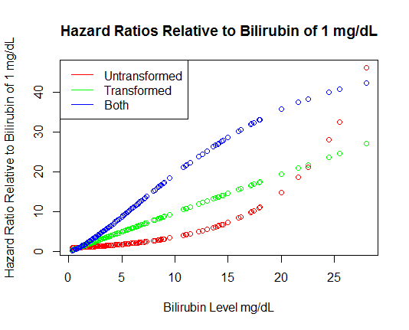
Notice that the untransformed model and the model including both the transformed bilirubin and untransformed bilirubin level look to have a curvilinear relationship with the log base e hazard ratio relative to someone who has a bilirubin level of 1 mg/dL. In contrast, the log base 2 transformed model looks to have a strong linear relationship with log base e hazard ratio. All models show a positive association between hazard ratio and bilirubin level, but for the purposes of proportional hazards regression, the log base 2 transformed bilirubin looks like the best model.

7. a) In our descriptive statistics in problem 1, we discovered that age and sex in our sample of PBC+ people enrolled in our study are associated with all-cause mortality, or hazard. Being older and being male were found to be associated with higher hazard. Since both age and sex are associated with hazard, there is the potential for either age or sex or both to confound the relationship between bilirubin and hazard.

b) In our descriptive statistics in problem 1, we discovered that age and sex in our sample of PBC+ people enrolled in our study are associated with all-cause mortality, or hazard. Being older and being male were found to be associated with higher hazard. Since both age and sex are associated with hazard, there is the potential for either age or sex or both to give added precision to determining the relationship between bilirubin and hazard.

c) Methods: We compared the distributions of time to death from any cause across groups defined by log transformed (using log base 2) bilirubin level at time of study enrollment using proportional hazards regression treating our log transformed bilirubin as a continuous variable. Before performing the regression we transformed bilirubin levels using log base 2. We also adjusted for age and sex in our regression model, including a term for age as a continuous variable and sex and a binary variable (1 for female, 0 for male). 106 of the 418 subjects were missing data for sex, so only the 312 subjects for which we have data on sex are included in the analysis. Our determination of association is based on the estimated hazard ratio from the regression model along with 95% confidence intervals and a two-sided Wald p-value using robust standard errors.

Results: From our proportional hazards regression using robust standard errors, we estimate that the instantaneous risk (hazard) of death is 111% higher in subjects who had a two fold increase in bilirubin level at the time of study enrollment. Based on our 95% confidence interval also using robust standard errors, this 111% increase in hazard for subjects who had a two fold increase in bilirubin level at the time of study enrollment would not be surprising if the true population increase in hazard of death was between 84% and 142% higher for people who had twice the bilirubin level of another person. Note that in this case our population is everyone who is PBC positive. These analyses may not be generalizable to the entire population. Our two-sided p-value < .0001 further suggests that we can reject the null hypothesis that bilirubin level and hazard of death are independent among people who are PBC+. This data suggests that higher levels of bilirubin are associated with a higher hazard of death. It should also be noted that by adjusting for age and sex, the estimated slope for log base 2 transformed bilirubin is further from 0 than without adjusting for age and sex. Since we are doing proportional hazards regression, this increase in estimated slope is expected, and is not evidence that age or sex confounds the relationship between bilirubin and hazard. However, our estimated robust standard error for the slope of our log base 2 transformed bilirubin term is higher at .0695 than it was for our unadjusted analysis which was .0553. This could be an indication that either age or sex or possibly both could be variance inflating variables. In this case, adjusting for them gives us less statistical precision. Given that the p-value for testing the slope of the sex term is .8006, sex may be our variance inflator in this example.

8. The intervention in the RCT could have greatly affected our analysis. Some of our subjects were given experimental medication while the other subjects were given placebos. Our analysis was based on analyzing the association between bilirubin levels and all-cause mortality in people who are PBC+. The medication could cause differences in all-cause mortality and bilirubin levels. If the medication caused both higher bilirubin levels and higher hazard, we may be picking up the association in the treatment group even if no true association exists in the population of PBC+ people. In order to determine this, we could stratify on treatment status and see if we get similar associations between bilirubin and all-cause mortality.

